SVEUČILIŠTE U ZAGREBU

**FAKULTET ELEKTROTEHNIKE I RAČUNARSTVA**

FINAL WORK br. xxxx

**DEVELOPING A WORKOUT PLANNER WEB APPLICATION**

Dalijo Vorkapić

Zagreb, mjesec 2022.

Introduction 1

1. Related work 2

2. Technologies 4

2.1 Development environment 4

2.1.1 IntelliJ IDEA 4

2.1.2 Visual Studio Code 6

2.2 Development framework 7

2.2.1 Java Spring Boot Framework 7

2.2.2 Angular framework 9

3. Requirement specification 14

3.1 Functional requirements 15

3.1.1 Actors and their functional requirements 15

3.1.2 Use cases 16

3.1.3 Use case diagram 16

3.2 Non-functional requirements 17

4. System architecture and design 18

4.1 Database 19

4.2 Server-side 20

4.2.1 Models 22

4.2.2 Data access 25

4.2.3 Request handling 28

4.3 Client-side 30

5. Implementation 31

6. Conclusion 43

Bibliography 44

Summary 45

Sažetak 46

# Introduction

In the last few years, there has been a great increasing interest of people in physical activities, such as sports, exercising and training, and they have all become an important part of their lives. With the initial appearance of the coronavirus, people suddenly had much more time and comfort for themselves, and many of them started with the so-called self-care routines. The main part of most of these routines, the one that has been preserved and grown to this day, is individual training. It is popular because, first of all it is very healthy and beneficial for human body and mind, it requires little to no equipment, it can be performed anywhere, at home, outside or in the gym, and it does not necessarily require a personal coach, since all the guides can be found online, and the person can come up with its own plan. By that approach, people need to put together their own exercise and workouts details, plans and schedule, as well as monitor their progress, usually through tracking the number of repetitions and sets of specific exercise, or by tracking the required training execution time. It takes a lot of time, thought and energy, and the final product, usually turns out to be disorganized, incomplete, and difficult to update and keep the track of, taking into account that planning, writing and tracking is done with a classic pen and paper, note application or with an excel spreadsheet.

Since we live in the age of the Internet, where various services are available to the users through web applications, The Web Workout Planner application will serve as a solution to the mentioned problem of monitoring progress and organization of the workouts because it reduces the complexity of performing the mentioned actions and it offers insight into the user statistics of workouts, to help track the progress better.

This work presents the process of developing a Web Workout Planner application, although its template can be applied to any type of personal planning and progress tracking application.

The Web Workout Planner application development process is presented in stages, and it will be based on the Software development lifecycle (SDLC) process, which consists of a detailed plan describing requirements analysis, requirements specification, architecture designing, product implementation and product testing and deployment.

Requirement specification will be carried out using the defined functional requirements of the application and by combining them with the use cases. Architecture of the application will be divided into the 3 groups: database, backend (“server-side”) development and frontend (“client-side”) development.

The aim of this paper is to present the full process of software development and to deliver a complete and stable user web application.

# Related work

There are many great examples of applications that are similar in theme and structure to this application. Such applications have elements like data grouping, scheduling events, progression tracking, and more. The most examples come from the same domain, the domain of recreational exercising. For the start, My Workout Plan mobile application. It is the application for managing exercise, creating routines, playing the workouts, and recording and showing the process. The application views and options are shown in *Figure 1.1*.

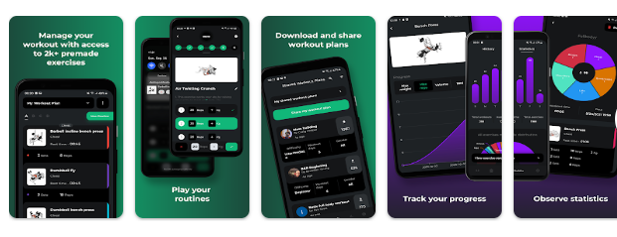

Figure 1.1: My Workout Plan mobile application

The next, more domain general application for scheduling events, is Google Calendar. It is a time-management web application that allows the user to view and organize the schedule, and to keep the track of events. The Google Calendar interface is shown in *Figure 1.2*.

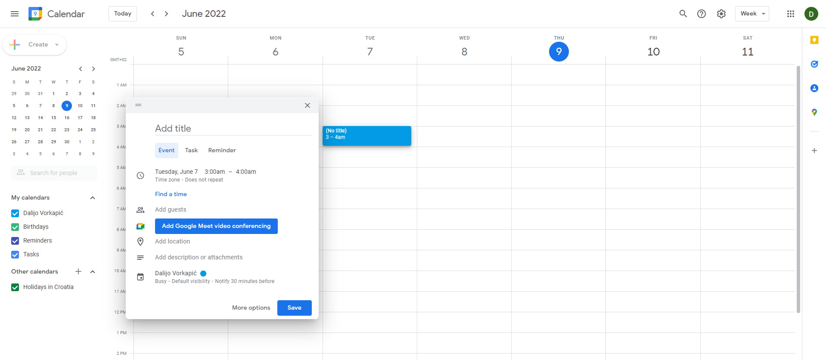

Figure 1.2: Google Calendar interface

# Technologies

With the aim of developing a full-stack web application, a wider set of technologies to use are needed. Full-stack development refers to the development of a complete web applications. [1] Firstly, Java Spring Boot framework is used for application’s server-side programming. Developing, version controlling, testing, and executing Java server-side source code is done through the IntelliJ IDEA community edition development environment. Secondly, Angular TypeScript framework is used for developing application’s client-side. Its source code is developed, version controlled and executed through the Visual Studio Code source code editor. Thirdly, the database of the application is created through the PostgreSQL relational database management system. Lastly, Heroku cloud platform is used to deploy the application on the real-time server.

## Development environment

A development environment is a workspace that consists of a set of processes and programming tools for developing, testing, and debugging an application or program. [2] It provides developers with a user interface for tracking the development process. Their main goal is to facilitate the development, and to make the developing in a particular language easier, and more understandable.

### IntelliJ IDEA

IntelliJ IDEA is an integrated development environment (IDE) written in Java, for developing computer software written in JAR (Java Archive) based languages, like Java, Kotlin and Groovy. An integrated development environment is a software application that provides comprehensive facilities to developers for software developing. An IDE normally consists of a source code editor, build automation tools, debuggers, compilers, interpreters, etc. IntelliJ IDEA is designed by JetBrains, a Czech software development company which makes tools and development environments for software developing and project managing. [4] IntelliJ IDEA is available in two editions, as an Apache licensed community edition, and in proprietary commercial edition. It is on the top spots of the most popular developer environment tool ranking in the Stack Overflow’s “IDE of choice 2021” [3], and one of the commonly most used IDEs for server-side and Java programming.

IntelliJ IDEA offers wide area of features, such as good developing ergonomics, easy and simple project start up, keyboard shortcuts for everything, standard and custom user interface themes, accessibility, instant navigation, and search, source code versioning, supplementing the core functionality with additional plugins. Example of IntelliJ IDEA user interface is shown in *Figure 2.1*. One of the key features is the deep code insight. IntelliJ IDEA creates a virtual map of the project by indexing the initial source code. Using the information from the virtual map, it can detect errors, suggest code completion variants with precise context-awareness, perform refactoring, and more. Additionally, it comes with a powerful toolset for running, testing, and debugging the source code.

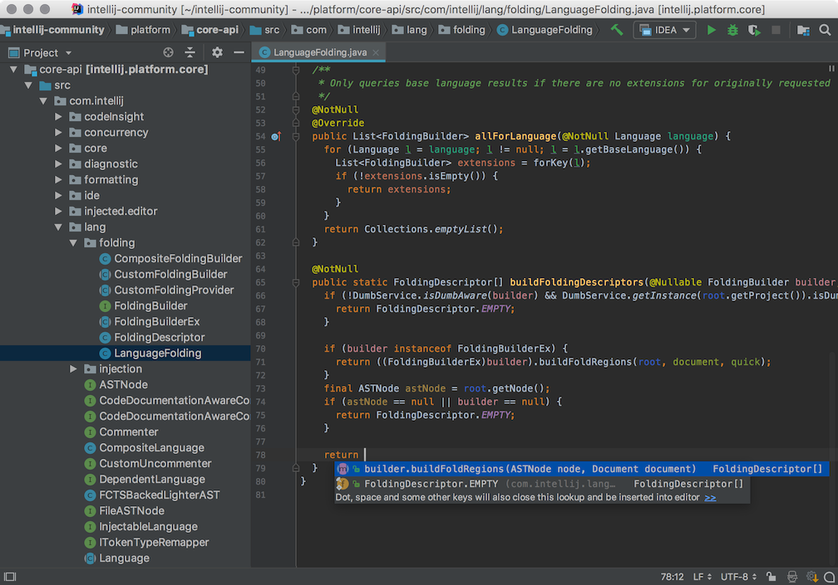

Figure 2.1:IntelliJ IDEA user interface

### Visual Studio Code

Visual Studio Code is a free source code editor developed by Microsoft. It was ranked as the most popular developer environment tool in the “IDE of choice” Stack Overflow 2021 Developer Survey [3], and it is one of the best choices in terms of web application client-side development, for which it is used in this project. Visual Studio Code helps the programmer in code writing, debugging, and it corrects the code using the intelli-sense feature, which can detect if any snippet of code is left incomplete or undeclared. [5] It has built-in support for multiple programming languages and has a rich ecosystem of extensions for other languages and runtimes. It provides interactable and simple user interface, repository support, web-support, it offers hierarchy file structure, and terminal, git, and multi-projects support. The advantage of Visual Studio Code over other source code editors and IDEs is his robust architecture, it is light-weight, fast, responsive, and interactive, and most importantly, completely free of cost. Example of Visual Studio Code user interface is shown in *Figure 2.2*.

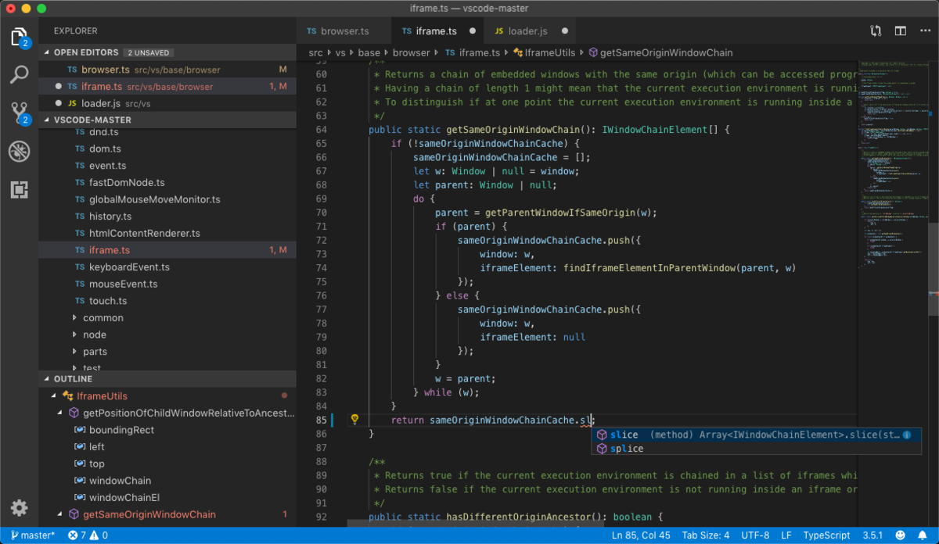

Figure 2.2: Visual Studio Code user interface

## Development framework

Development framework is a software structure that consists of sets of tools and libraries, that provide a fundamental structure to support the development of application for a specific environment.

### Java Spring Boot Framework

Java Spring Boot is a development framework based on the Spring framework. [6] Spring Framework is an open-source Java-based framework used to create a micro service, which is an architecture that allows the developers to develop and deploy services independently, meaning each service running has its own process. Spring Framework offers built-in support for typical tasks an application needs to perform, such as data binding, type conversion, validation, exception handling, resource, and event manager, and more. Since that regular Spring Framework requires significant time and knowledge to configure, set up and deploy Spring backend application, Spring Boot Framework mitigates this effort, by making the developing of web application and microservices with Spring Framework faster and easier. It achieves it with: autoconfiguration, meaning that application is initialized with pre-set dependencies that do not need to be configured manually, opinionated approach, meaning it adds and configures starter dependencies, based on the project needs, without requiring the developer to make all those decisions and set up everything manually, and thirdly, it helps developers to create standalone applications that run on their own by embedding a web server during the initialization process, without the need of an external web server, making the whole application launchable on any platform with ease.

Spring Boot follows a layered hierarchical architecture in which each layer communicates with the layer directly below or above. [7] Diagram of layered architecture is shown in *Figure 2.3*. There are four abstract layers in Spring Boot, presentation layer, business layer, persistence layer, and database layer.

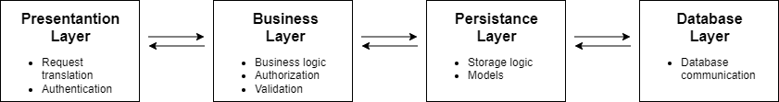

Figure 2.3: Spring Boot layers hierarchy

The presentation layer consists of controllers. Each controller handles its own HTTP requests, such as POST, GET, UPDATE, DELETE, through the specified paths. Example of controller is shown in *Code 2.2*. The data is sent and received in JSON format. JSON (JavaScript Object Notation) is a lightweight, language independent text format for storing and transporting data, it consists of objects that have their set properties with their included values. JSON example is shown in *Code 2.1*.

‘{“name”:”John”, “age”:30, “interests”:[“hiking”, “sports”, “cars”]}’

Code 2.1: JSON example

The presentation layer, with the intention of processing the data, translates the JSON parameters into Java objects, which are then transferred to the deeper layer of logic, the business layer.

@RestController

class EmployeeController {

private final EmployeeService service; //business layer

. . .

@GetMapping(“/employees”)

List<Employee> getAllEmployees() {

return service.getEmployees();

}

@PostMapping(“/employees”)

Employee addNewEmployee(@RequestBody Employee newEmployee) { //mapping JSON

return service.saveEmployee(newEmployee); //object to the

//Employee model

}

Code 2.2: Controller class example

The business layer handles all the business logic as well as authorization and validation. In terms of application logic, it consists of service classes that handle the functions defined through the persistence layer, that are linked with the database communication. Example of the service class is shown in *Code 2.3*.

@Service

public class EmployeeService {

private EmployeeDataAccessObject employeeDAO; //reference to the

//persistence layer

. . .

public List<Employee> getEmployees() {

return employeeDAO.fetchEmployees();

}

. . .

}

Code 2.3: Service class example

The persistence layer contains all the storage logic and data access services. It directly communicates with the database layer, and it translates the objects received from the business layer or from the database layer into the models which are then sent further deeper or higher into the hierarchy. “Example of the data access service is shown in *Code 2.4*. The database layer is database itself, in which all CRUD (Create, Retrieve, Update, Delete) operations can be performed.

@Repository()

public class EmployeeDataAccessService implements EmployeeDataAccessObject {

private final JdbcTemplate jdbc; //reference to the database layer

//accessor

. . .

@Override

public List<Employeee> fetchEmployees() {

final String sql=”SELECT * FROM emplooyes”;

List<Employee> employees = jdbc.query(sql,…). . .

Return employees;

}

. . .

}

Code 2.4: Data access service class example

### Angular framework

Angular is a component-based platform and a framework built on TypeScript, used for building single-page scalable client web applications using HTML and TypeScript language. It is a collection of well-integrated libraries that cover a wide variety of features, including routing, forms management, client-side communication, as well as a suite of developer tools to help in developing, building, testing, and updating the source code.

Angular apps are modular, which means each Module defines a set of associated Components. [8] A Component controls a patch of the screen called a View, defined through the HTML template. Angular creates, updates, and destroys Components as the use moves through the application. Example of Component class declaration is shown in *Code 2.1*.

@Component ({

selector: ‘my-component’

templateUrl: ‘./my-component.component.html’

})

export class MyComponent implements OnInit {

// Component code  
 }

Code 2.5: Component declaration

A Service class is a part of Angular that handles and defines things that can not fit into a Component and find their reason to exist in the separation of concerns. Their purpose is to help in dividing the application into small, different logical reusable units. Service declaration example is shown in *Code 2.1*.

export class TicketService {

getTickets() { return tickets; }  
 addTicket(ticket: any) { tickets.push(ticket); }  
 deleteTicket(ticket: any)) { tickets.pop(ticket); }  
 }

Code 2.6: Service declaration

One of the larger subjects of Angular is Dependency Injection, a design pattern in which one or more dependencies are injected into a dependent object. Such pattern is applied when it is wanted to separate actions of what-to-do part of the when-to-do part. Angular uses his its own Dependency Injection framework which is divided into three parts: the injector, the provider, and the dependency. For example, injecting different required services into the different components, or registering a provider of any service being used, thus creating dependency. Dependency Injection between service and a component example is shown in *Code 2.3*.

import { Injectable } from '@angular/core';  
 import { TicketService } from './ticket-service';

@Injectable()  
 export class TicketService {

getTickets() { return tickets; }  
 addTicket(ticket: any) { tickets.push(ticket); }  
 deleteTicket(ticket: any)) { tickets.pop(ticket); }  
 }

. . .

import { Component } from '@angular/core';  
 import { TicketService } from './ticket-service';

@Component({  
 selector: 'my-component',  
 templateUrl: './my-component.component.html',  
 providers: [ TicketService ]  
 })

export class HeroListComponent implements OnInit {  
 constructor(private ticketService: TicketService {}

// Component code  
 }

Code 2.7: Dependency injection example

Data Binding is another key feature of Angular, which allows properties of two objects to be linked so that a change in one causes a change in the other, like establishing a connection between the user interface (HTML) and the application. It defines relationship between a source object that provides the data and a target object that will use the data from the source object. Alongside regular data binding, Angular also provides event binding, for example, executing a component function on a button click event. Examples of data binding is shown in *Code 2.4*.

<h1>{{source_object_string}}</h1>

<button (click)="doSomething()">Do something</button>

Code 2.8: Data binding example

With the aim to perform actions when different moments occur, Angular provides lifecycle hooks as interfaces that can be implemented by any component. For example, moments like component initialization (OnInit) exit (OnDestroy), update (OnChanges), and more. Example of declaring initialization lifecycle hook is shown in *Code 2.5*.

export class MyComponent implements OnInit {

ngOnInit() {  
 // Some code to execute from the start  
 }  
 }

Code 2.9: Initialization lifecycle hook example

Alongside with components, Angular contains two more kinds of directives. Structural directives that change the structure of the view (NgFor, NgIf). Example of structural directives is shown in *Code 2.6*. NgIf presents / hides the html component, based on the outcome of the attached expression (true or false). NgFor iterates over array of items, and for each item it creates the additional HTML element to which it is attached. The other type are the attribute directives that are used as attributes of the HTML elements, for example NgClass and NgStyle.

<div *ngIf="character" class="name">{{character.name}}</div>

<ul>  
 <li *ngFor="let character of characters">{{character.name}}</li>  
 </ul>

Code 2.10: Structural directives example

One of the Angular most usable features are observables, provided through the RxJS library, used for reactive programming where the data is in asynchronous streams. Observables provide support for passing the data between the publisher and the subscribers in the application. Firstly, on the publisher side, an observable data stream is defined, usually as a subject or the observable. Through that stream, publisher can send asynchronous or regular data. On the other end, components that require that data will subscribe to the subject and “wait” for data to be sent through the stream. Once it is sent, the subscribers receive it, and they can store it in their component variable. Example of a subscription action is shown in *Code 2.7*. Received data through the subscription can come in three variants, as a passed value, an error or as a completed subscription. Various functions in regular return an observable to which components can subscribe, for example, http operation methods.

import { Observable } from 'rxjs/Rx'  
 import { Injectable } from '@angular/core'  
 import { Http } from '@angular/http'

@Injectable()

export class TicketService {

constructor(public http: Http) {}

public getTickets() {

return this.http.get('/api/tickets') //returns an Observable

}

. . .

export class MyComponent {

constructor(public ticketService: TicketService) {}

ngOnInit() {  
 this.ticketService.getTickets().subscribe({ //three outcomes

next(response){},

error(err) {},

complete() {}

})  
 }  
 }

Code 2.11: Observables action example

Angular also offers two types of forms, reactive forms, and template driven forms, alongside with their validation options. Lastly, without mentioning many other possibilities and features Angular contains, for navigating between the component views, Angular uses the routing module. Example of component routes is shown in *Code 2.8*.

import { RouterModule, Routes } from '@angular/router';

const appRoutes: Routes = [  
 { path: 'characters', component: CharactersComponent },  
 { path: 'character/:id', component: CharacterDetailComponent },  
 { path: '', redirectTo: '/characters', pathMatch: 'full' },  
 { path: '**', component: PageNotFoundComponent }  
 ];

@NgModule({  
 imports: [  
 RouterModule.forRoot(appRoutes)  
 ]  
 })  
 export class AppModule { }

Code 2.12: Routes example

# Requirement specification

Requirement specification is the first phase of software development. It is a collection of all requirements that are to be imposed on the design and verification of the application. A requirement is a thing that product must do (“system shall do”) or a quality it must have (“system shall be”). It is determined by the requirements engineering process, which analyzes, structures, documents, and verifies user-required system services and usage constraints. Based on the content, each requirement specification can be divided into function and non-function requirement. Differences between functional and non-functional requirements are shown in *Table 1.1*.

Table 1.1: Functional vs. Non-functional requirements

|  |  |  |
| --- | --- | --- |
|  | **Functional requirements** | **Non-functional requirements** |
| Objective | Describe what the product does | Describe how the product works |
| End result | Define product features | Define product properties |
| Focus | Focus on user requirements | Focus on user expectations |
| Documentation | Captured in use case | Captured as a quality attribute |
| Essentiality | Mandatory | Not mandatory, but desirable |
| Origin type | Usually defined by user | Usually defined by developers |
| Testing | Component, API, UI testing | Performance, usability, security testing |
| Types | Interface, authentication,  authorization levels, etc. | Usability, scalability, reliability,  Performance, etc. |

## Functional requirements

A functional requirement is a description of the service that the software must offer to the stakeholder (actor). It describes a software system or its component. A function is nothing but inputs to the software system, its behavior, and outputs.

For this application, we define actors with their corresponding functional requirements. Initiator is the type of actor that directly interacts with the system, while participant does not interact, and it only gets passively affected by system.

### Actors and their functional requirements

**Actors:**

* Initiators
  + Administrator
  + User
* Participants
  + Database

**User can:**

* Login to the application
* View the data of:

1. Workouts
2. Exercises
3. Schedule
4. Statistics

* Create, update, and delete data of:

1. Workouts
2. Exercises
3. Scheduled workouts

**Administrator can:**

* Everything that user can
* Manage users
  1. Register new users
  2. Remove users

**Database:**

* Saves all data from the application
* Deletes selected data
* Updates selected data

### Use cases

A use case is a written description of how users will perform tasks on the website. It outlines, from a user's point of view, a system's behavior as it responds to a request. Each use case is represented as a sequence of simple steps, beginning with the user's goal, and ending when the goal is fulfilled. Use cases add value because they help explain how the system should behave, and in the process, they also help brainstorm what could go wrong.  They provide a list of goals, and this list can be used to establish the cost and complexity of the system.

### Use case diagram

A use case diagram is part of UML behavioral diagrams, which depict the elements of a system that are dependent on time and that convey the dynamic concepts of the system and how they relate to each other, such as graphical depiction of a user's possible interactions with a system, which was previously mentioned through the use cases. Application’s use cases UML diagram is shown in *Figure 3.1.*

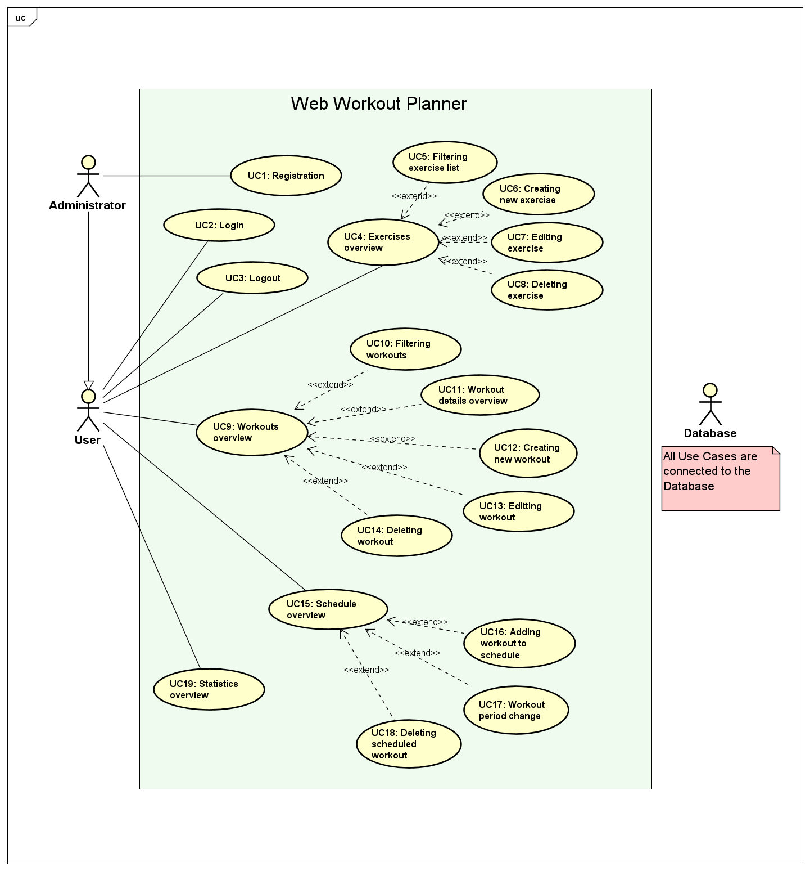

Figure 3.1: Application's use case diagram

## Non-functional requirements

A non-functional requirement is a specification that describes the software’s operation capabilities and constraints that enhance its functionality, such as performance, security, reliability, usability, scalability, and maintainability.

**Application’s non-functional requirements:**

* Performance
  + Single page application
  + Fast communication with database
* Scalability
  + Application can stand high workload
* Availability
  + Application is always online
  + Multiple users possible in real time
* Reliability
  + No unexpected crashes
* Security
  + Authentication
  + Password hashing
  + Input validation
* Usability
  + Minimalistic and simple user interface

# System architecture and design

The architecture of this application can be divided into the following components, shown in the architecture layout in *Figure 4.1.*

* Server side (backend)
* Client-side (frontend)
* Database

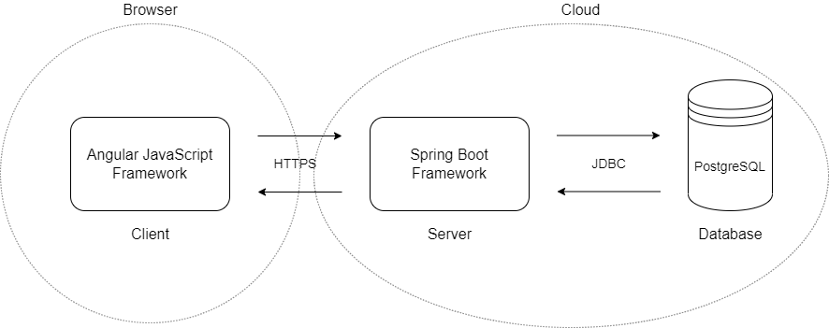

Figure 4.1: Architecture layout

## Database

A database is an organized collection of structured information, or data. It is controlled by a DBMS (Database Management System). The most used type of the database is a relational database. The data within it is typically modeled in rows and columns in a series of tables to make processing and data querying efficient. The data can be easily accessed, managed, modified, updated, controlled, and organized. Most relational databases use structured query language (SQL) for writing and querying data. SQL provides querying, manipulation, data defining and access control of the database.

The database used for this application is PostgreSQL. It is a free and open-source relation database management system (RDBMS) emphasizing extensibility and SQL compliance.

Application’s database consists of the next entities:

* AppUser
* Workout
* Exercise
* Progress
* Schedule

Since entities need to connect with each other, it is necessary to determine the relations. Entity Relationship Diagram is shown in *Figure 4.2.*

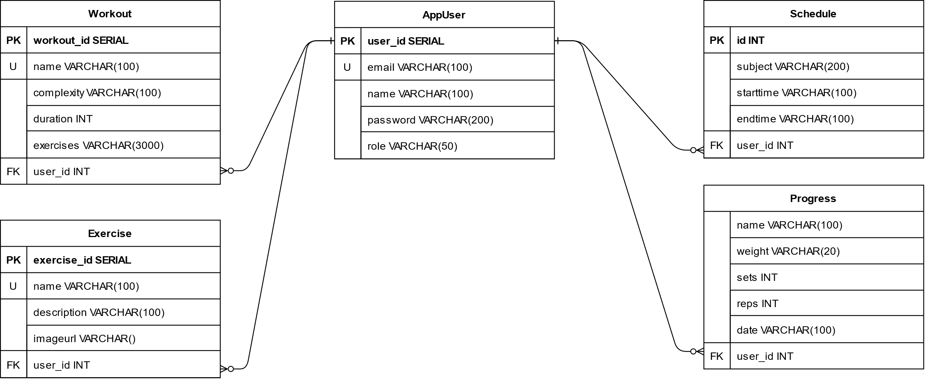

Figure 4.2: Entity relationship diagram

## Server-side

Server side is the main component of this application. In it lies the program logic to deliver to the user what he requested for. The complete backend program is built with Java Spring Boot Framework.

Server side communicates in two directions. In one direction, it communicates with the database, while in other, it communicates with the client. Such communications are achieved by using APIs. The API (Application Programming Interface) is a mechanism that enables two software components to communicate with each other using a set of definitions and protocols. There are four different ways that APIs can work, like the most popular one, REST API.

Regarding this application, Spring Boot is RESTful, meaning it can be based on the REST API approach. REST (Representational State Transfer) is an architectural style that defines a set of functions like GET, POST, PUT DELETE, etc. that web clients use to access the server data. They exchange data using HTTP.

With the aim of Spring boot server-side application to be RESTful, it needs to follow six guiding principles (constraints) of the REST architecture:

1. Uniform interface – generality of the system architecture, visibility of interactions
2. Client-Server design pattern – enforces the separation of concerns, can be evolved independently
3. Statelessness – server does not save client data between requests
4. Cacheable – response should label itself as cacheable or non-cacheable
5. Layered System – architecture composing of hierarchical layers by constraining component behavior
6. Code on Demand – allows client functionality to extend

Application’s server side is divided into four layers:

1. Controllers
2. Services
3. Data access services - repository
4. Data access objects

Client side communicates with server side, through the HTTP request made to the URL defined by the controllers. Controller than proceeds the data from the request to the Service, which implements the logic for handling the request. Service then uses the Data access service layer, with purpose of getting defined methods to process the request. Data Access Service creates the methods to communicate with the database, based on the methods defined in Data access object interface. In terms of communication with the database, it uses JDBC (Java Database Connectivity) API, which connects and executes queries with the database. Server-side layers are shown in *Figure 4.3.*

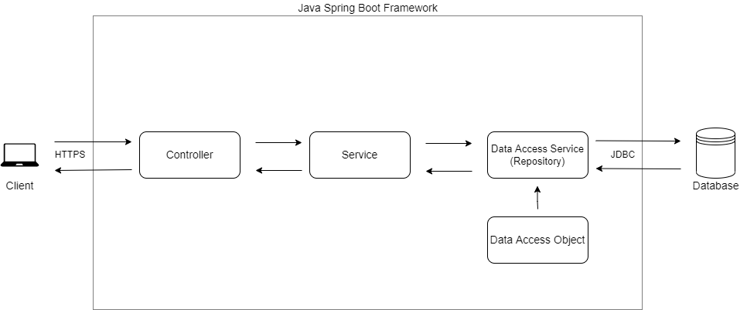

Figure 4.3: Server-side layers

Application’s server-side structure is organized into packages. [9] A Java package is a namespace group of similar types of classes, interfaces, and sub-packages. In this application, they group classes and interfaces that belong to the same layer of data handling. Server-side consists of the main com.fer.hr.zavrsni package, which contains sub-packages: api, dao, datasource, model, repository, security, securityfilter, service, and the main application. Directories and package structure is shown in *Figure 4.4.*

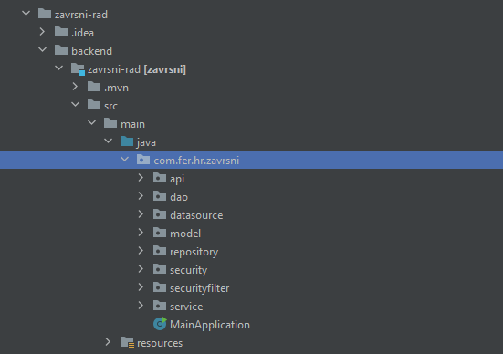

Figure 4.4: Server-side directory structure

Api package represents controllers, dao and repository contain the persistence layer handlers, content inside service handles the business layer of the application, models represent the overall data structures, while security and securityfilter handle authentication and authorization processes of application.

### Models

With the aim of understanding, manipulating and transferring the received data, there needs to be a data representation. A model class is a representation of data object which can be used for transferring data through the application. It encapsulates direct access to data in object and ensures that all data in object is accessible through the getter methods. Server-side models are shown in *Figure 4.5.*

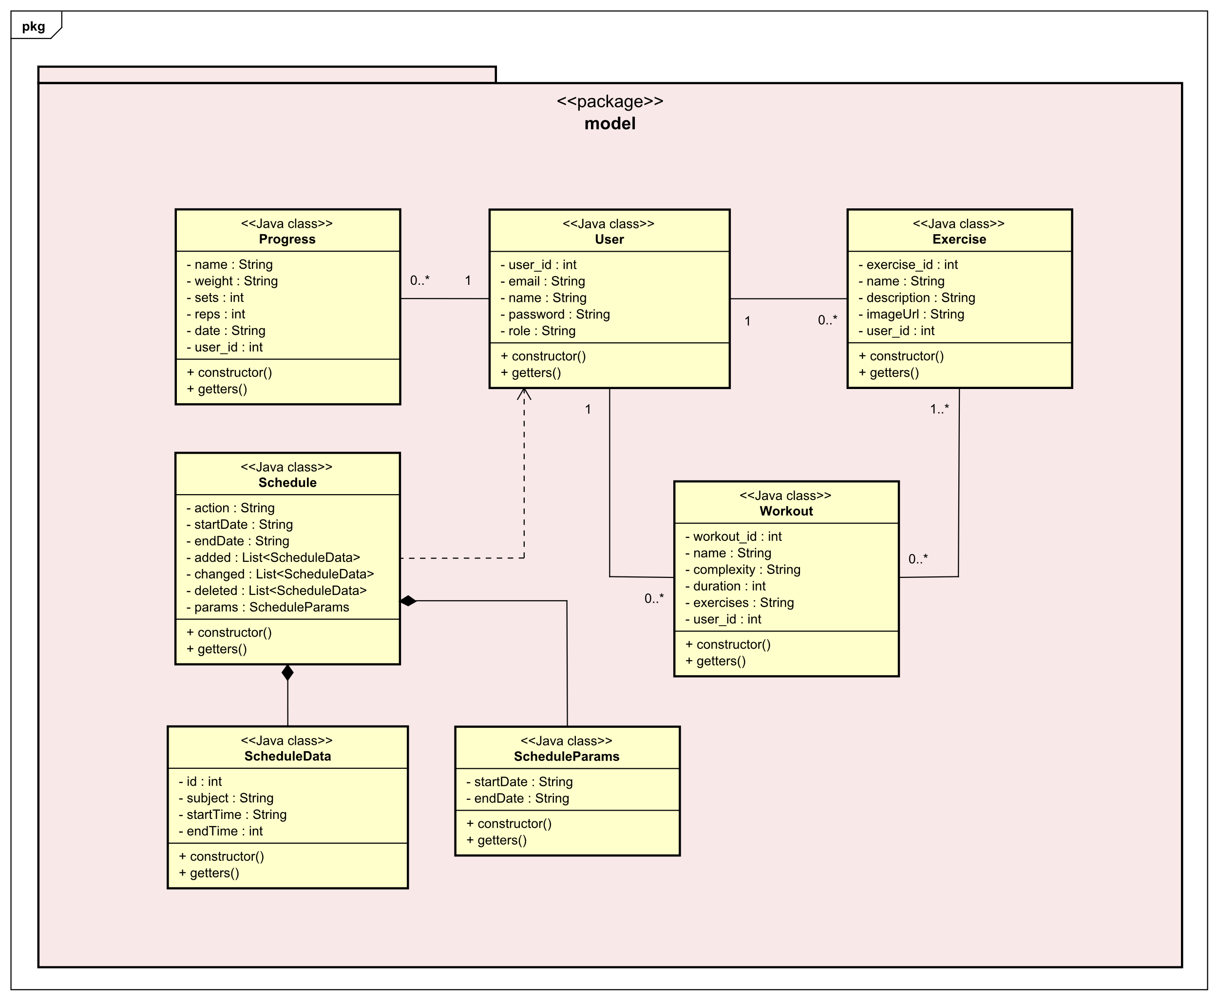

Figure 4.5: Server-side models UML class diagram

User model represents the registered user in application. Each user contains unique id, email, password, and one of two possible roles: ROLE_USER or ROLE_ADMIN. Depending on the role, user has different privileges through the application.

Exercise model represents the exercise created by specific user. It contains unique id, exercise name, description, link to the image related, and the id of user that created it. The connection between exercise and user model is represented with one – zero to many relations, meaning one specific user can create from zero to many exercises, while one specific exercise can be created by one user.

Workout model represents the workout created by specific user. Regarding attributes, it contains its own unique id, workout name, complexity, duration in minutes, list of attached exercises with additional attributes specific to the workout, and those are weight, sets and reps, and the id of user that created the workout. Connection between user model and workout model is represented with one – zero to many relations, meaning that one specific user can create from zero to many workouts, while one specific workout can be created by only one user. Workout model is also connected with the exercise model, through zero to one - one to many relations, which means that one specific workout can contain from one to many exercises, and one specific exercise can belong to zero to many workouts.

Progress model represents the model for handling each inserted progress for specific exercise. It terms of attributes, it contains unique exercise name, weight, exercise sets and reps, and the id of user that created the exercise progress. Progress model is connected through zero to many – one relation with the user model, meaning that one user can create between zero and many progresses, and that one progress model can be created by only one specific user.

Schedule model represents the model for handling schedule events, such as getting events, storing, deleting, and updating. It contains requested action attribute, parameters, schedule view start and end dates, and three list attributes that depend on the schedule action, and those are added, deleted, and changed.

ScheduleData model represents the actual individual event data from the schedule, which is sent through the list of events. That is why it is connected to the schedule model through the composition, meaning its object existence is depending on the existence of the schedule model’s object. ScheduleData model contains event id, subject, that is, event name, and start and the end of the event. Schedule model is in composition with ScheduleParams module as well, since ScheduleParams is needed to define the params attribute of the Schedule model. It contains parameter start and end date.

Each model, alongside the attributes, contains its own constructor function, as well as the corresponding getter functions for public retrieval of the values from its private attributes. Example of a model is shown in *Figure 4.6.*

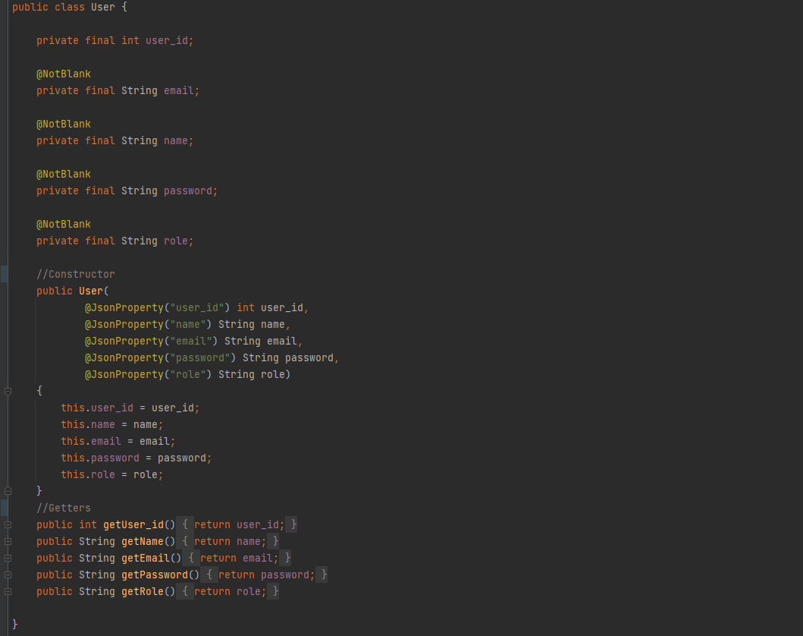

Figure 4.6: User model class

### Data access

After defining the models for representing the data objects, the next step is to define the logic to transfer that data, that is, to receive and send the data.

The first thing to implement is the data access objects (DAO). It is an interface responsible for encapsulating the details of the persistence layer, and for providing data manipulation interface (create, update, and delete operations) for each entity. Application’s data access object interfaces are stored inside the DAO package. Example of DAO interface is shown in *Figure 4.7.*

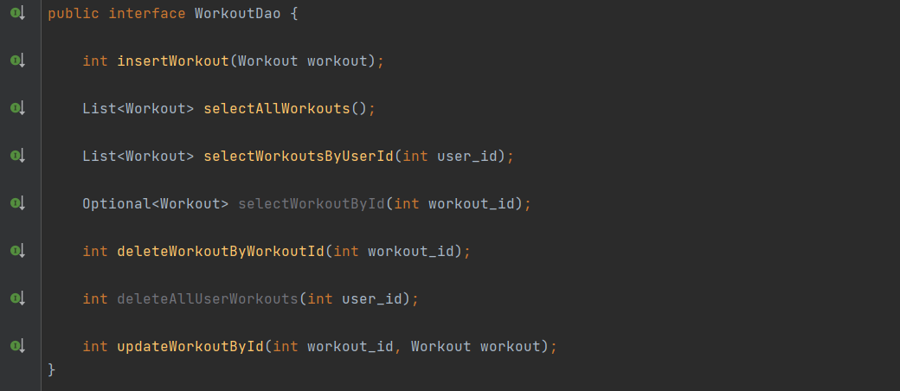

Figure 4.7: Workout DAO interface

The next step is defining classes that will be an actual implementation of the DAO interface. Such classes are called data access services because they provide the service logic for data accessing and handling. Regarding the application, they are stored inside the repository package. Data access services, or repository classes, are in charge of communication with the database through overriding pre-defined, DAO interface functions. The communication is established through the Java JDBC API. It stands for Java Database Connectivity, and it is a Java API for connecting and executing queries with the database. It connects to the database through its JDBC driver. JDBC API can perform database statements updates and the retrieval of the received results from the database. Data access service stores received database data inside the pre-defined models. Example of data access service with JDBC is shown in *Figure 4.8.*

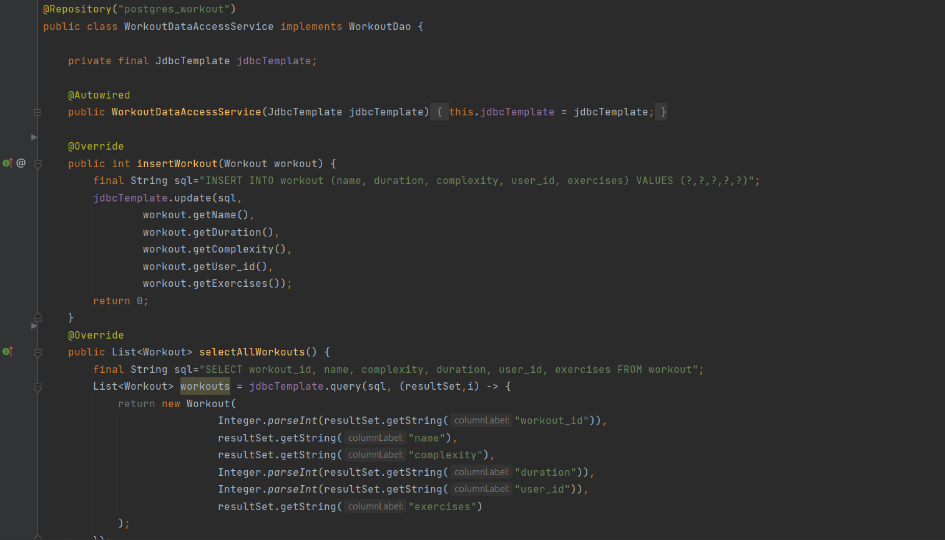

Figure 4.8: Workout data access service class

Given the figure above, @Repository Spring annotation indicates that the class contains logic for storage data manipulation, so it can be autodetected by spring framework through class path scanning. @Override annotation denotes that the child class method overrides the base class method, in this case the child being WorkoutDataAccessService, and the base class WorkoutDao.

Regarding the database connectivity, Spring Boot provides Hikari, a JDBC data source implementation that provides a connection pooling mechanism in combination with PostgreSQL driver, for successful connection with the PostgreSQL application database. Example of database connection properties is shown in *Figure 4.9*, and Hikari configuration in *Figure 4.10.*

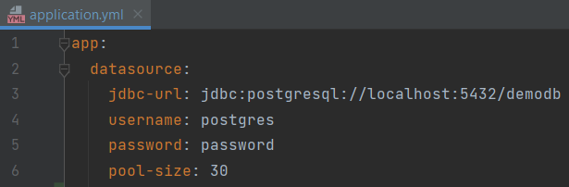

Figure 4.9: Example of database connection properties

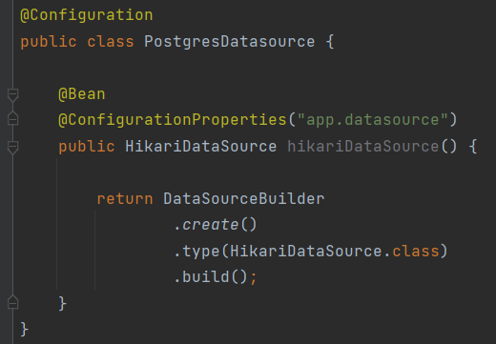

Figure 4.10: Hikari configuration

Given the figure above, @Configuration annotation indicates that a class declares one or more @Bean annotation methods and may be processed by the Spring container to generate bean definitions and service requests for those beans. @Bean marks the methods for Spring to add to the context for us.

### Request handling

After successful defining the models and data access services with their logic, the next step is to use them through the request handling process. The request handling process is the main part of the presentation layer of overall Spring Boot application structure. The specific class is called a controller. In terms of the request, it comes from the client-side, in form of HTTP request. Controller contains functions to handle different HTTP requests, like POST, PUT, DELETE, GET, on different URL paths. Inside the function, controller maps the request or response payload to the model object, and it passes it further, either to the business layer’s services, or back to the client-side. This application has its controllers stored inside the api package. Example of controller is shown in *Figure 4.11.*

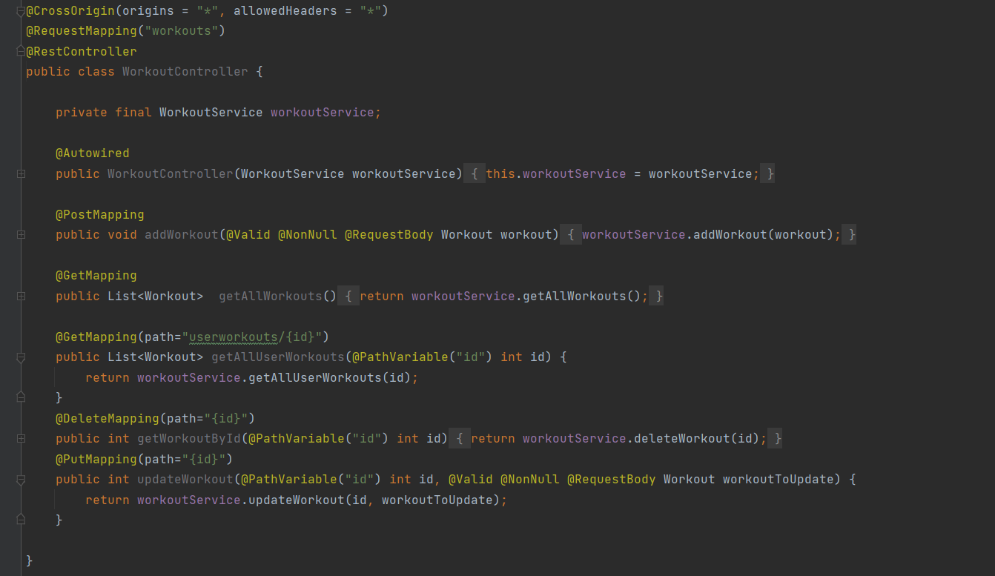

Figure 4.11: Workout controller class

Regarding the figure above, @RestController annotation indicates to Spring that this class handles the requests made by the client. @RequestMapping annotation is used to map web request path to Spring controller methods. Regarding the functions, @PostMapping indicates that the function will handle HTTP POST requests. If no path specified, it is going to use the path given through the @RequestMapping. The post function’s parameter is annotated with @RequestBody, meaning it will map the JSON object from the request to the model object. If there is a dynamic part of path specified, for example id, inside the mapping annotation, the path variable is accessible through the @PathVariable annotation inside the function parameters.

As already mentioned, inside the business layer, the controller-sent requests are processed through the service classes.­ They contain the logic for handling the data, for example, setting and inserting the data, data manipulation, and more. The service class handles most of the functionalities through the data access object reference, with which it can send the received controller request all the way to the database and back. Example of service class is shown in *Figure 4.12.*

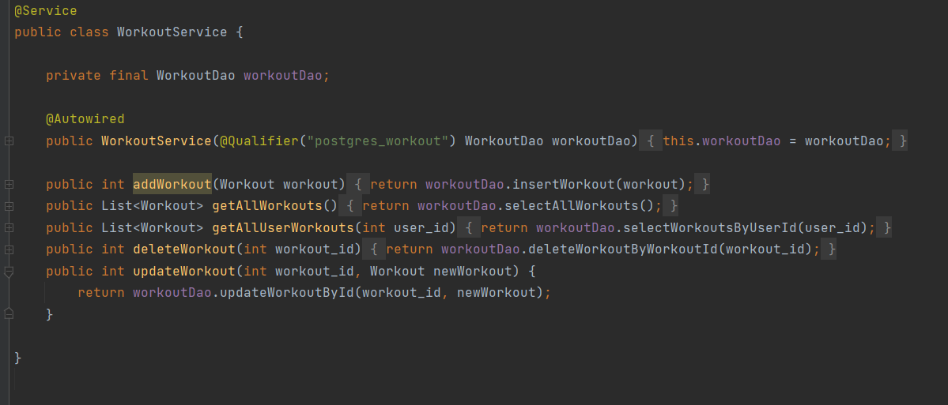

Figure 4.12: Workout service class

Given the figure above, @Service annotation lets Spring know that this class contains the business logic functionality. Through the @Qualifier annotation, it is specified which bean needs to be injected, based on the given name. In our application the service @Qualifier annotation is always linked to the @Repository annotation.

## Client-side

Client-side refers to everything in web application that is displayed or takes place on the client (end user device). This includes what the user sees (User Interface), along with any actions that an application performs within the user’s browser. Any client-side application is built on HTML (Hypertext Markup Language) markup language, which builds a website’s structure and renders a website in a browser. For designing the HTML, the default design language is CSS (Cascading Style Sheets), which adds visual design elements to a website. With aiming to make websites dynamic, responsive, and interactive, websites use JavaScript scripting language. It allows to dynamically add HTML contents to the DOM (The Document Object Model), which is a top to down representation of all the elements that make up a web page. It is the interface through which scripts interact with the HTML. Most of the webpages nowadays are not coded using JavaScript, but with its superset, TypeScript.

TypeScript is a better solution than JavaScript because TypeScript additionally offers:

* Type checking the code, generics
* It provides highly productive development tools
* Simplifies JavaScript code
* Structural

The complete client-side application is built using Angular. It is a TypeScript-based free and open-source web application framework, used for building single-page client applications. It is a complete rewrite from the AngularJS, and got improved in segments like:

* It uses a hierarchy of components as its primary architectural characteristic
* Modularity
* TypeScript language
* Dynamic loading
* Iterative callbacks provided by RxJS

Angular implements core and optional functionality as a set of TypeScript libraries than can be imported into the application. The architecture of an Angular application relies on certain fundamental concepts. The basic building blocks of the Angular framework are the components that are organized into modules, who collect related code into functional sets. Components define views, which are sets of screen elements that Angular can choose among and modify according to the program logic and data. Components use services, which provide specific functionality not directly related to views. Service providers can be injected into components as dependencies, making the code modular, reusable, and efficient. Angular also offers two-way data binding, for synchronization between the model and the view, dependency injection, routing, route protection, etc.

# Implementation

This section shows the final user interface of the application. *Figure 5.1* shows the login view of the page. By the successful login, user is redirected to the home page shown in *Figure 5.2*. If the login was unsuccessful, the user will be kept in the login page with proper error message, shown in *Figure 5.3*. On the home page user is prompted with a selection section. By clicking on Workouts Details, user is redirected to the Workout page, shown in *Figure 5.4*. User can create new workout through the form shown in *Figure 5.5.*

If user selects the Exercise option on the home page, he will be redirected to the exercises page shown in *Figure 5.6.* User can create exercise, as shown in *Figure 5.7.*

User can update or delete each exercise, through displays shown in *Figure 5.9* and *Figure 5.10.* The same update and delete operations are provided in the Workout page as well. User can also insert the exercise progression, through the form shown in *Figure 5.8.*

Next on the list is the Schedule page, also accessible from the home page. Its interface is shown through *Figure 5.11.* User can add a workout event by selecting the time frame of his workout and inserting the event name, as shown in *Figure 5.12.* User can also update the event and delete it.

Lastly, user has the Statistics page option, shown in *Figure 5.13.* By selecting the exercise, user can get the progression insight of it, shown in *Figure 5.14.*

Every user has the logout option available by clicking on his avatar, as shown in *Figure 5.15.* If the user has administrator role, he also has the manage user option, shown in *Figure 5.16.* By selecting it, administrator is redirected to the manage users page, *Figure 5.17,* where he can register, *Figure 5.18*, update, *Figure 5.20*, and delete, *Figure 5.19*, the users.

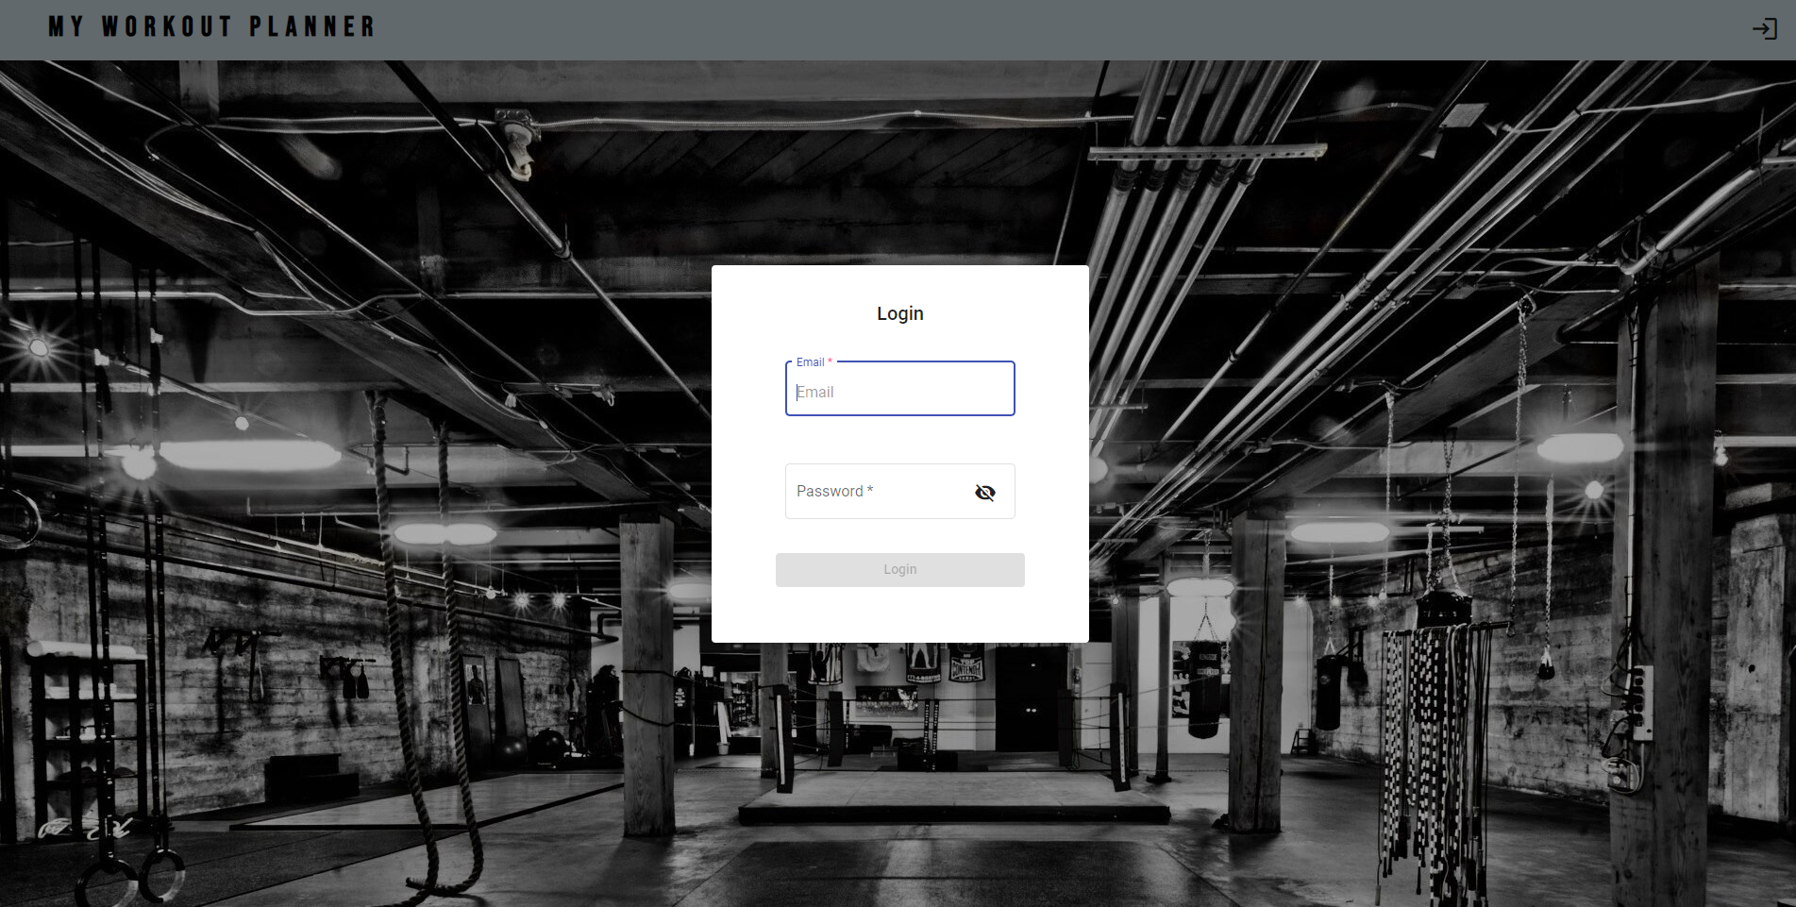

Figure 5.1: Login page

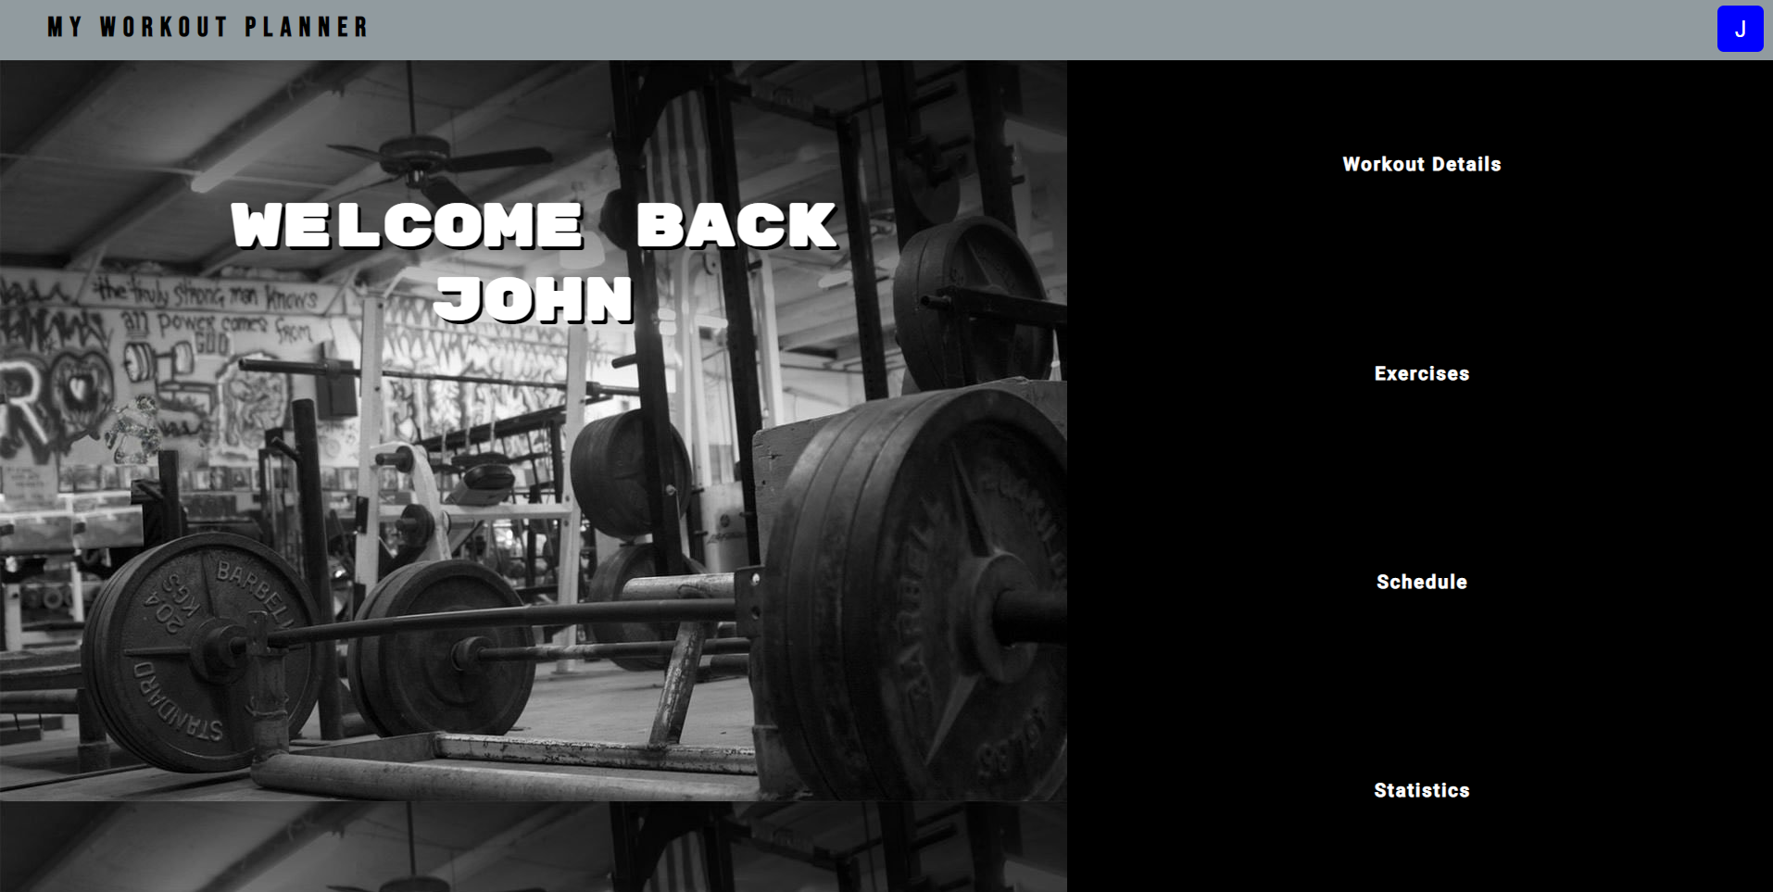

Figure 5.2: Home page

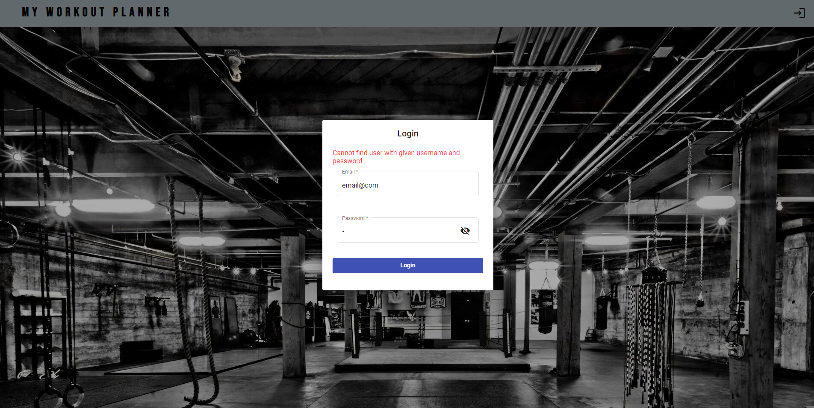

Figure 5.3: Login error

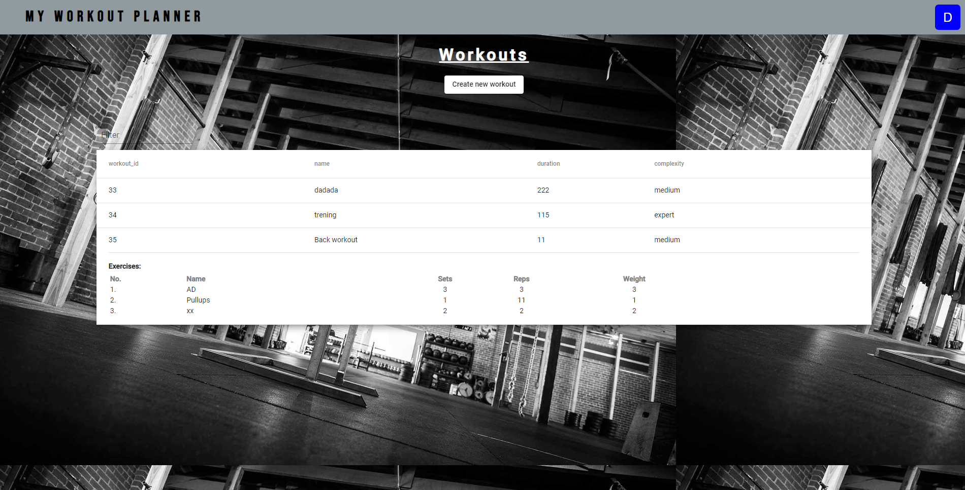

Figure 5.4: Workout page

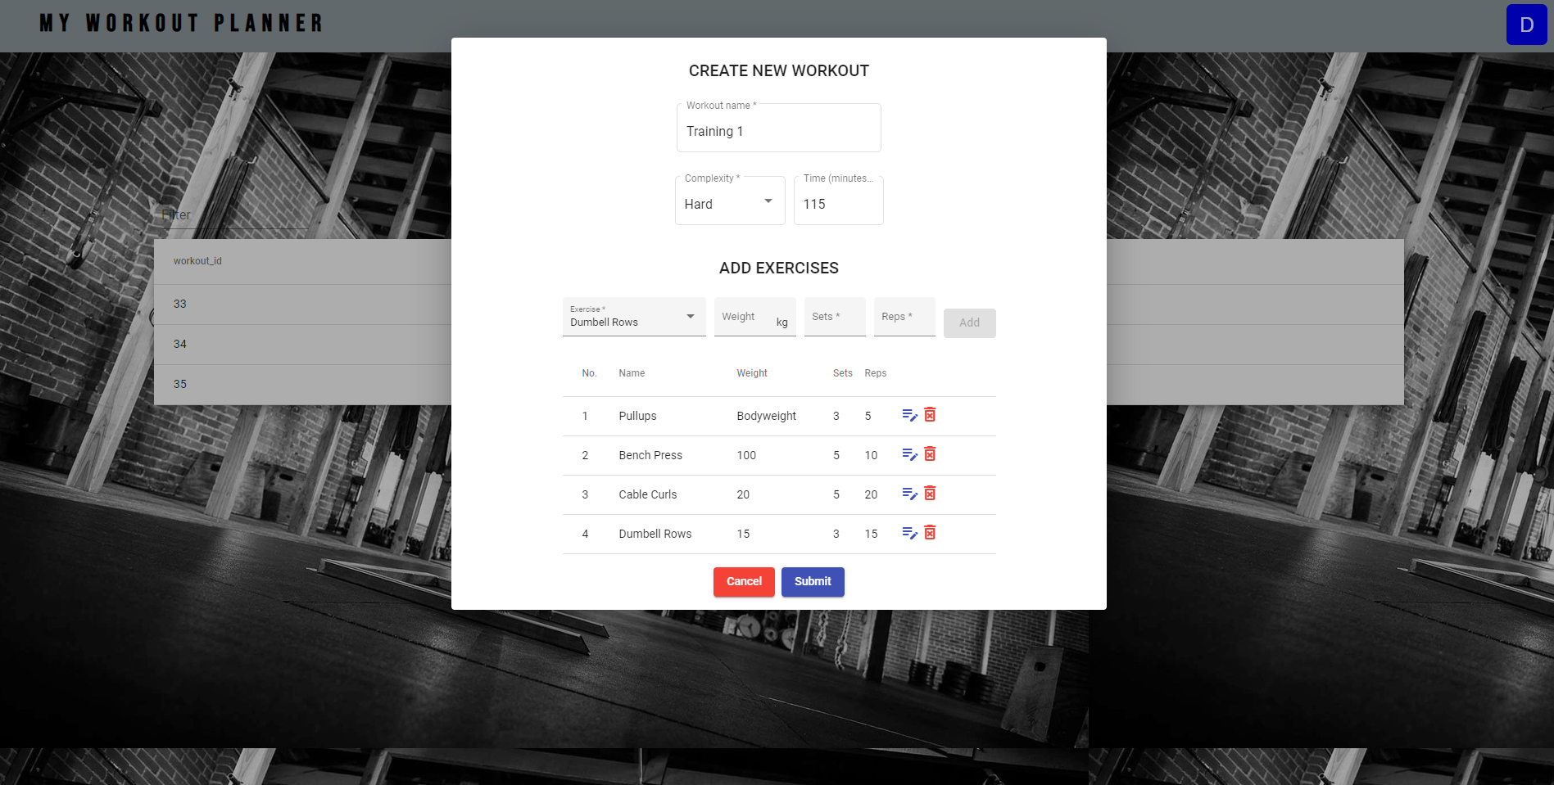

Figure 5.5: Workout creation

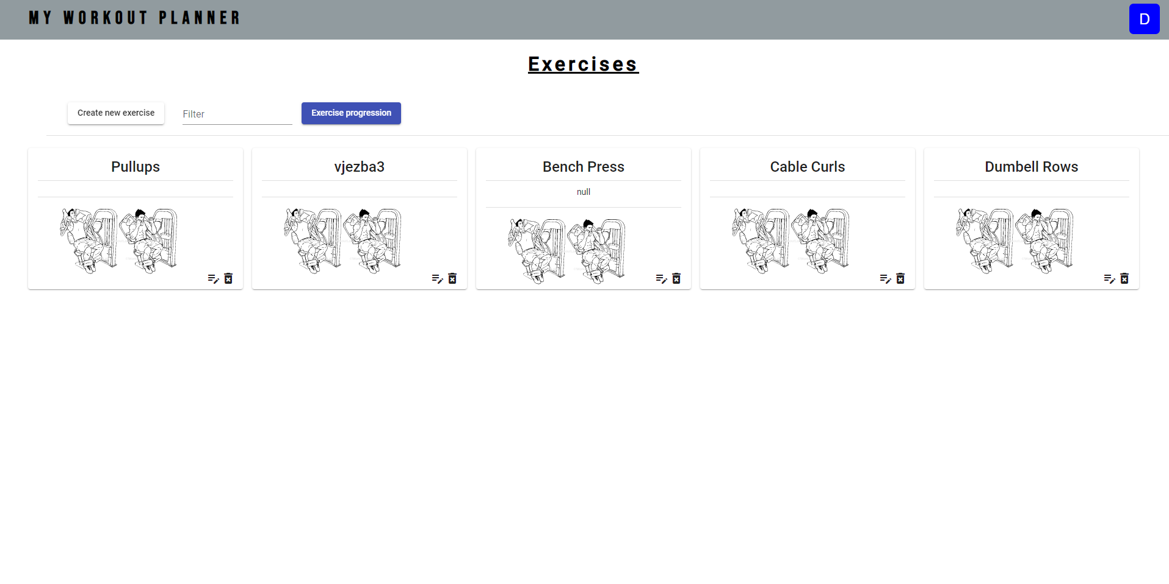

Figure 5.6: Exercise page

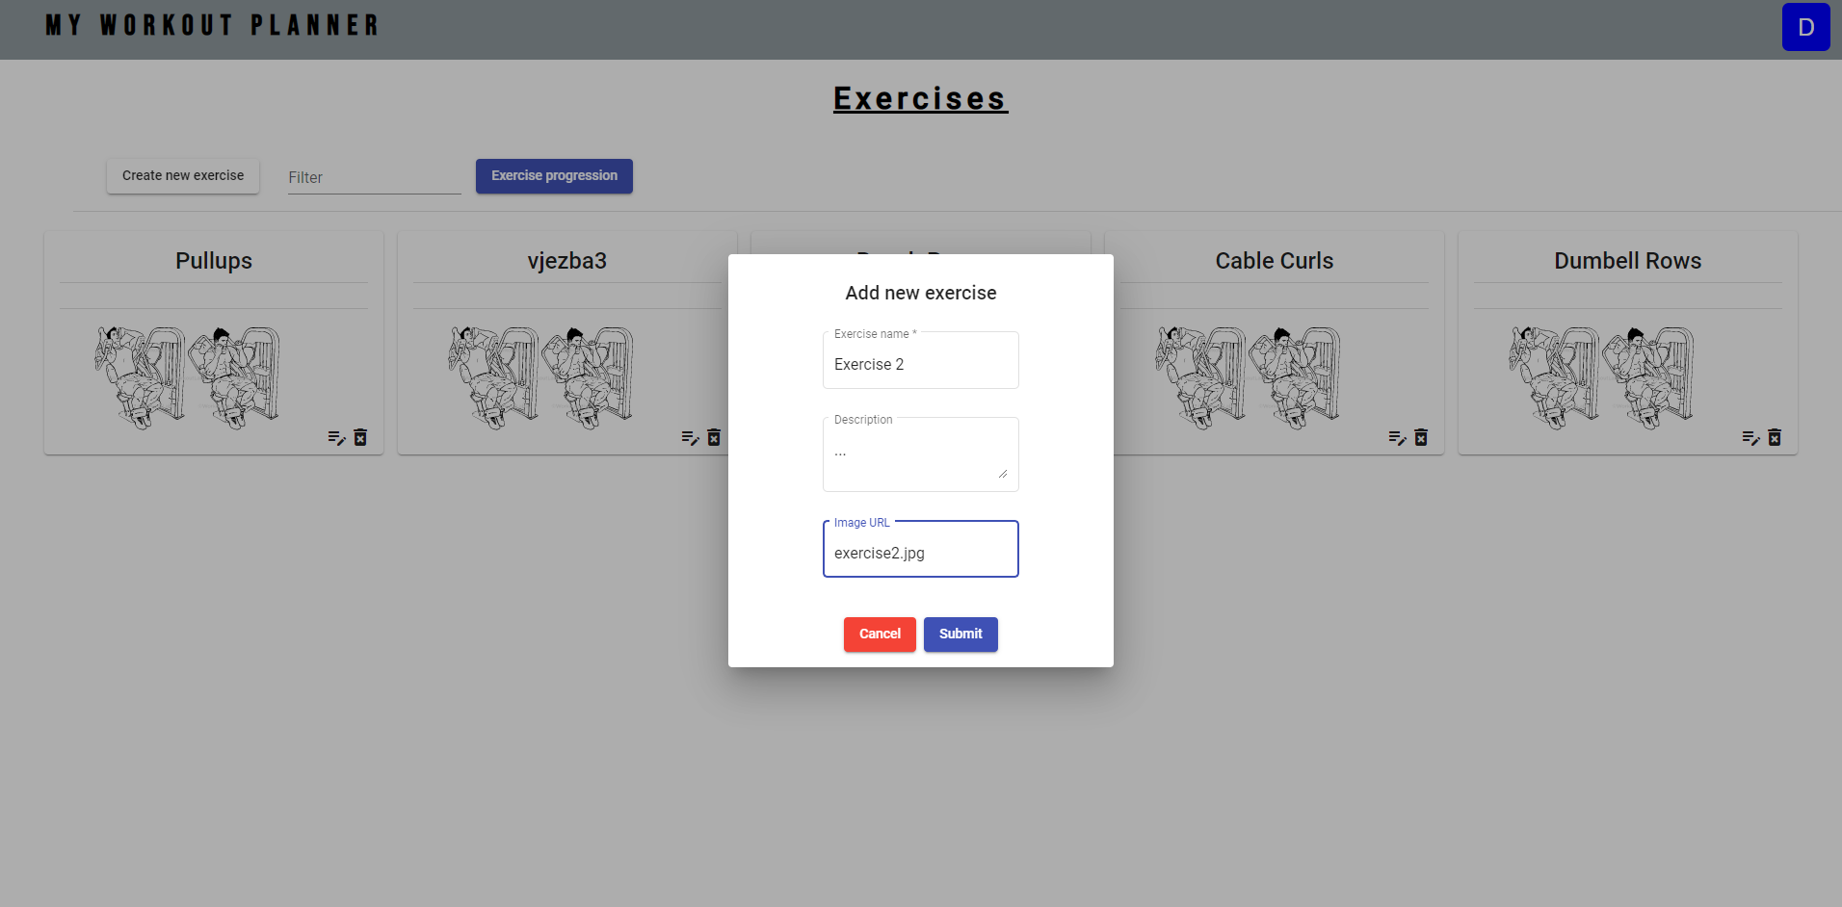

Figure 5.7: Exercise creation

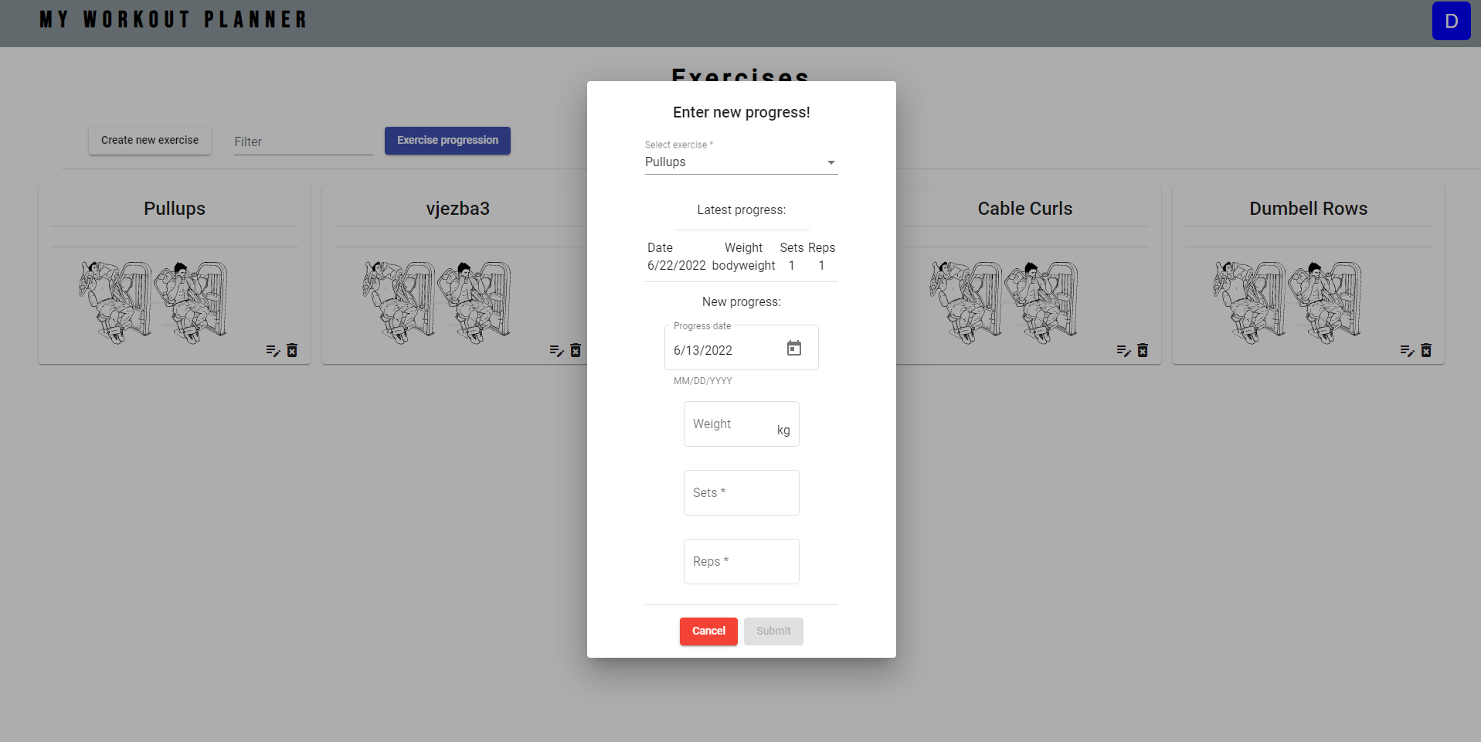

Figure 5.8: Exercise progression add

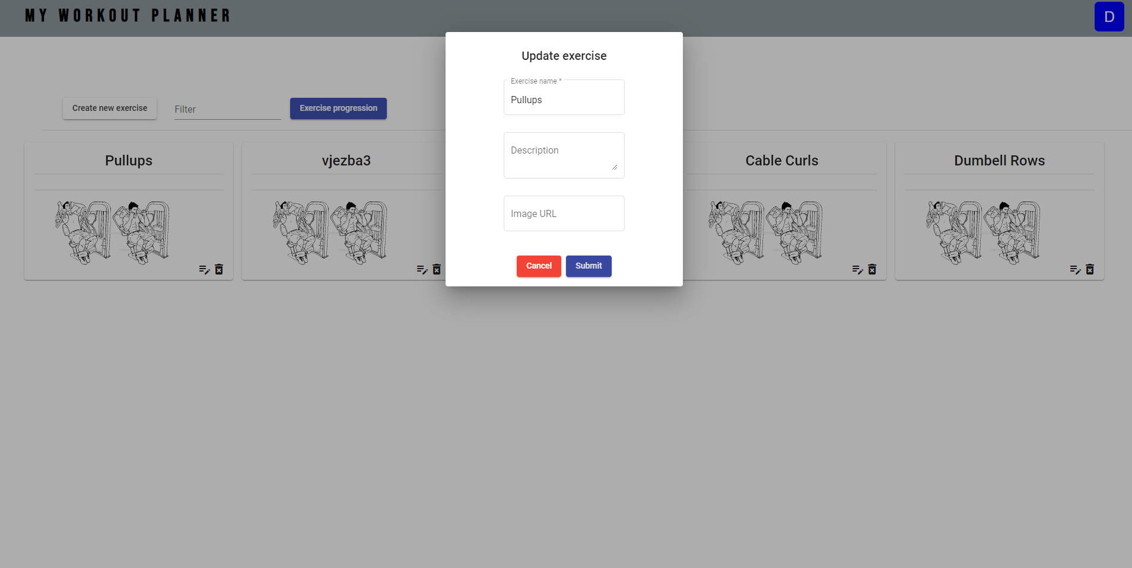

Figure 5.9: Exercise info update

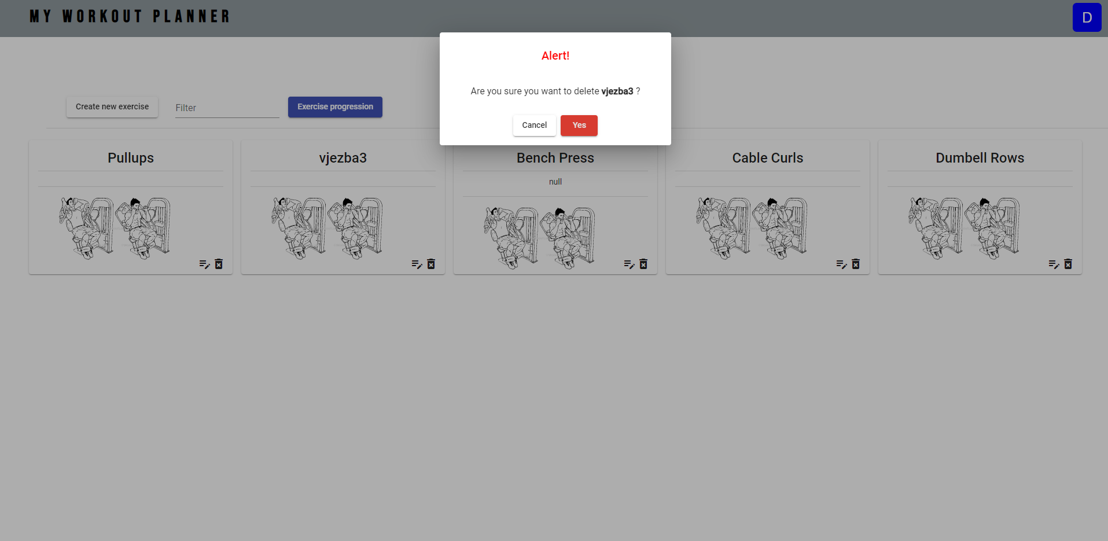

Figure 5.10: Exercise deletion

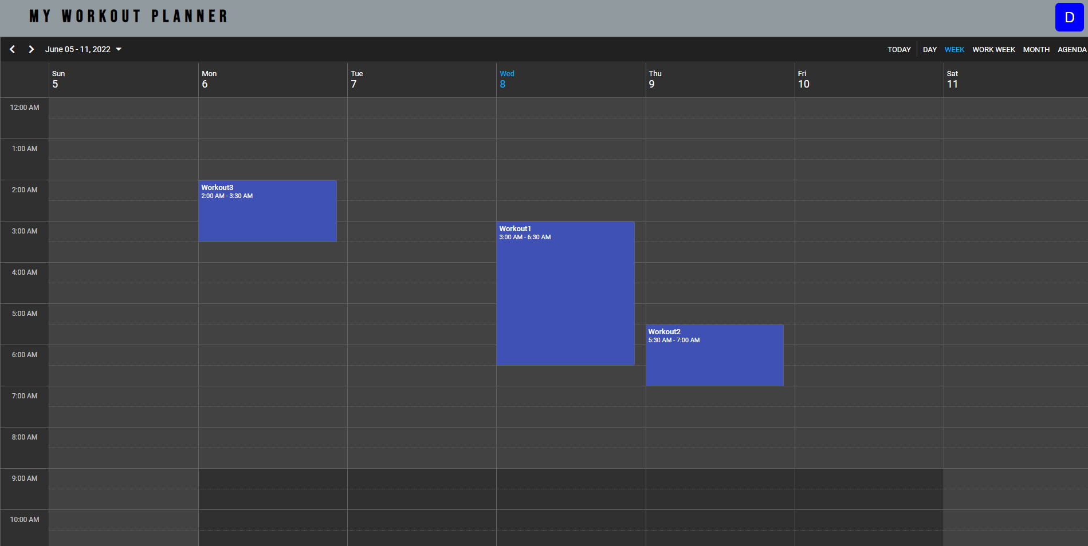

Figure 5.11: User schedule page

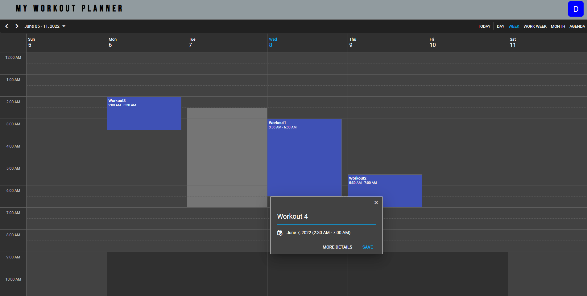

Figure 5.12: Adding scheduled workout

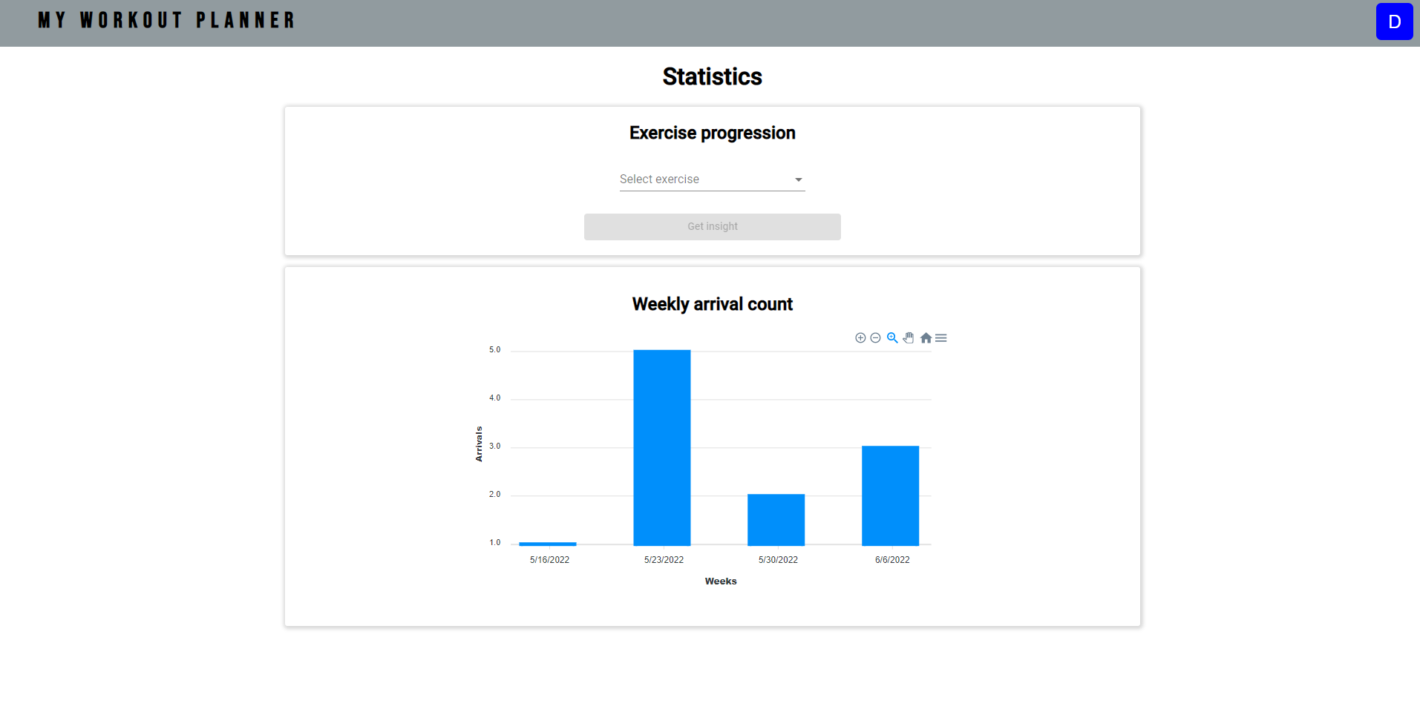

Figure 5.13: Statistics page

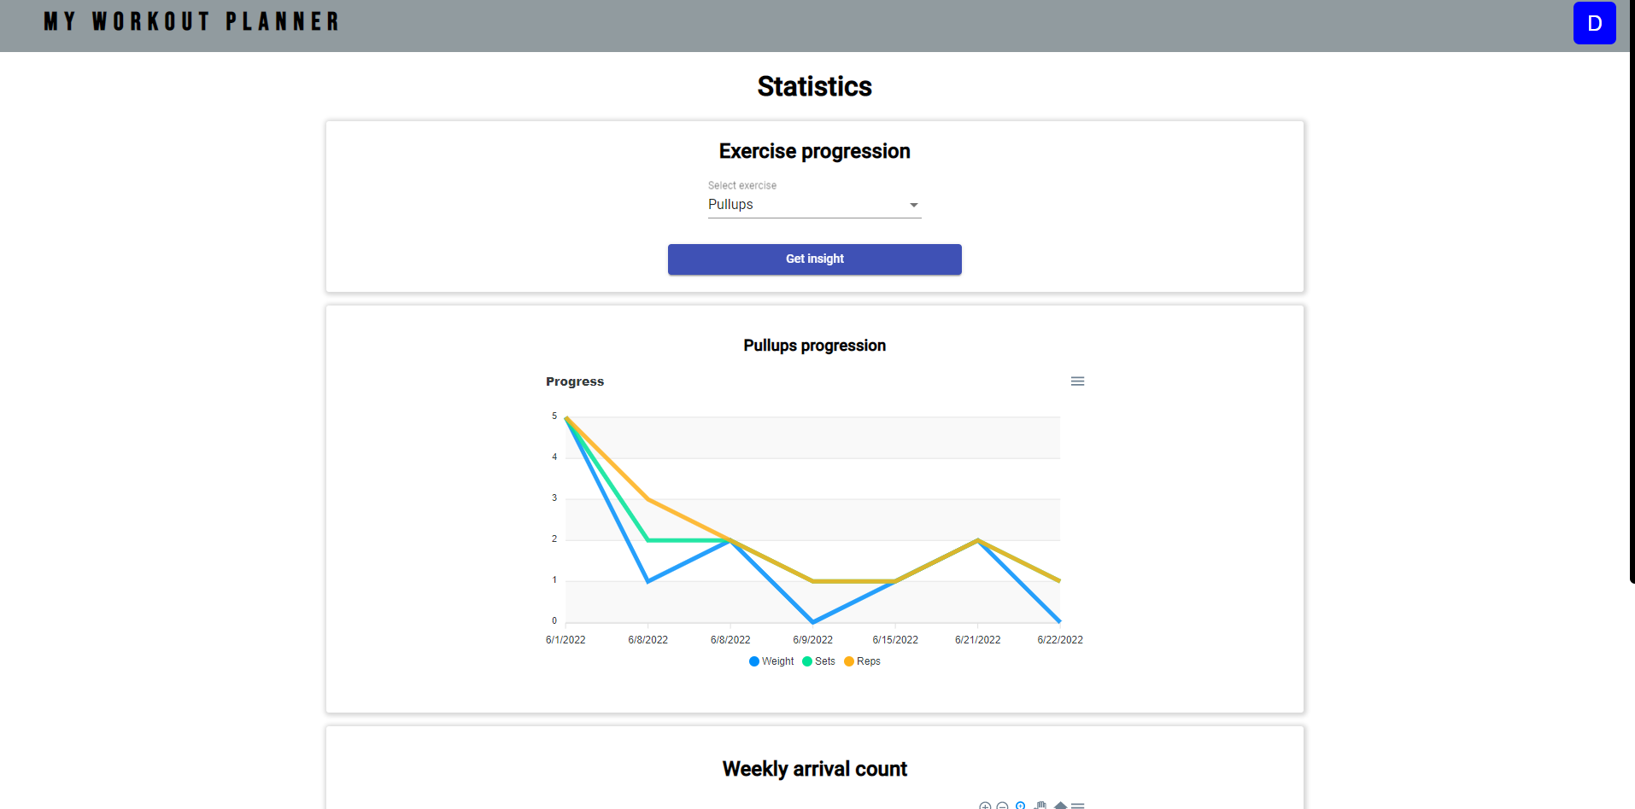

Figure 5.14: Statistics page with exercise insight

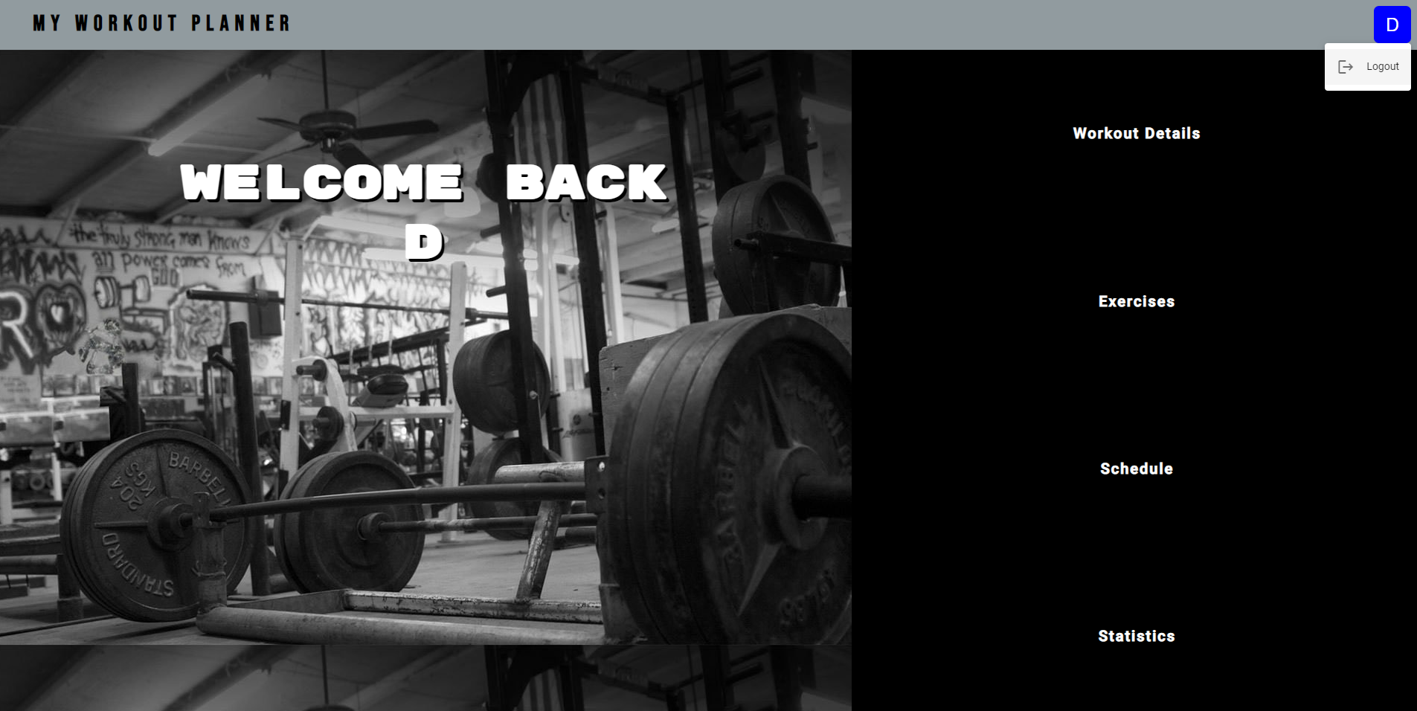

Figure 5.15: Logout option

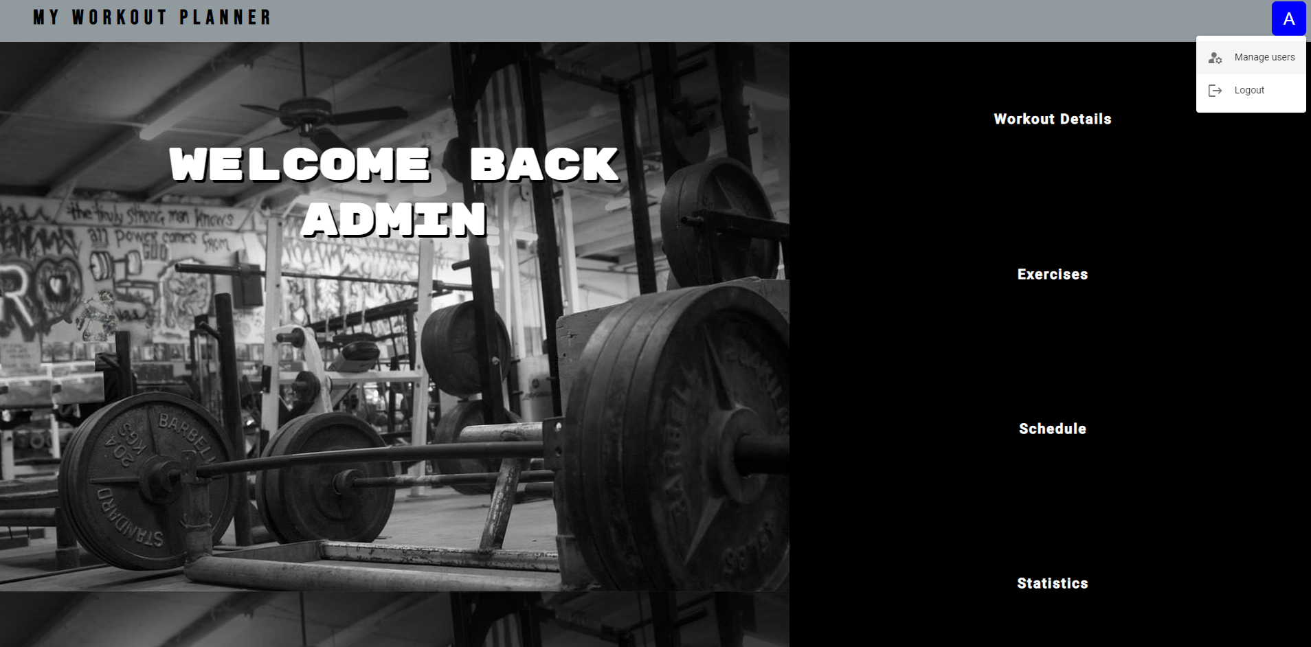

Figure 5.16: Admin manage users option

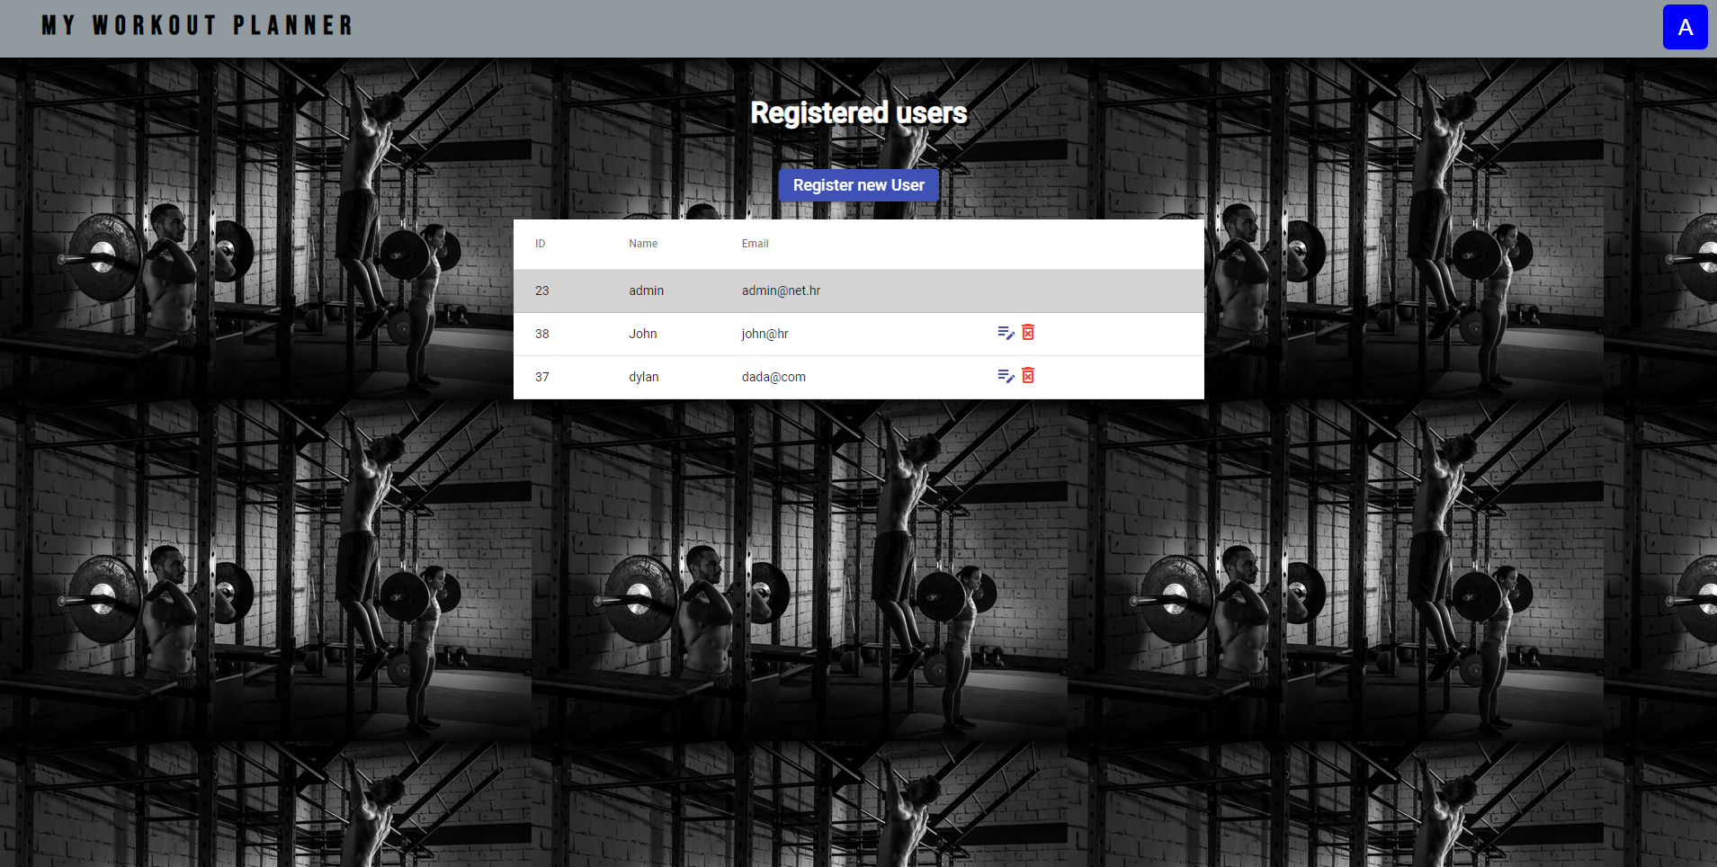

Figure 5.17: Manage users page

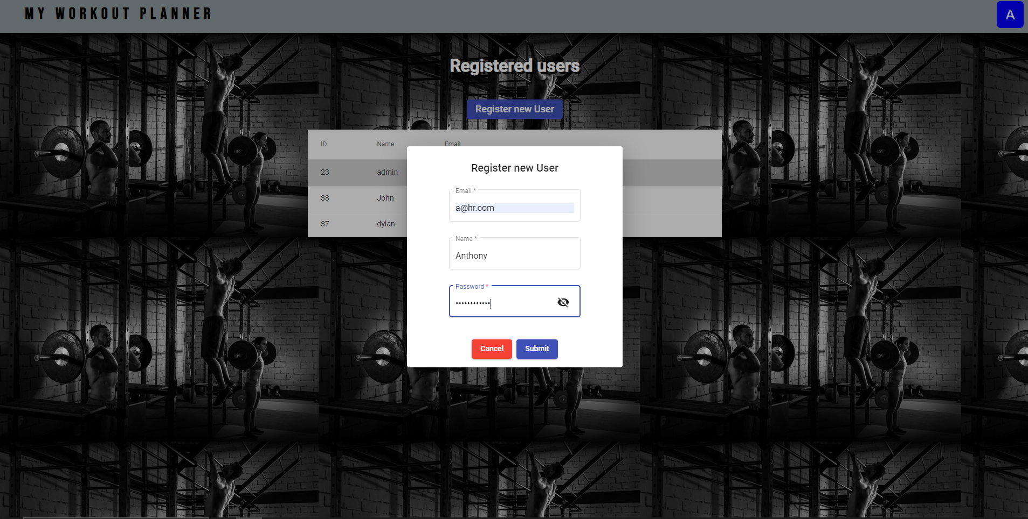

Figure 5.18: New user registration

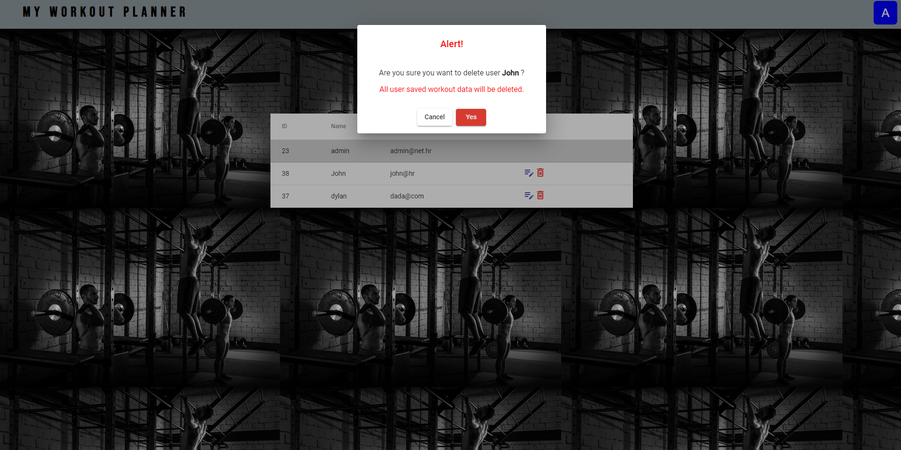

Figure 5.19: User deletion

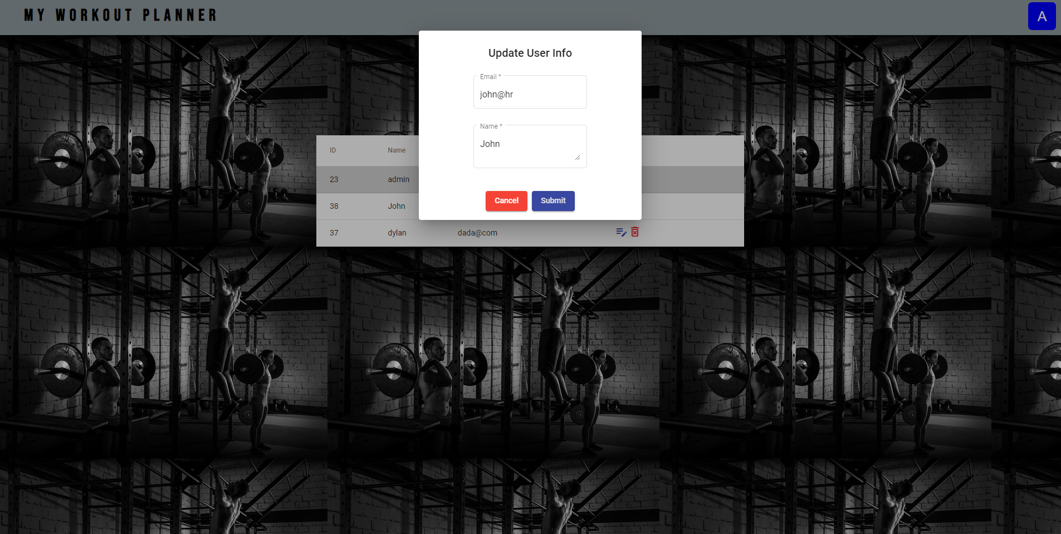

Figure 5.20: User info update

# Conclusion

Through this paper, the whole workout planner web application development process was shown. In addition to learning the developing process of web applications, other goal of this paper was exploring and learning new technologies from the world of web application developing. Since the architectural goal was to use the client-server architecture, the following technologies were chosen. Spring Boot framework for server-side development, and Angular framework for client-side development. With those two powerful tools, a complete, functional, and aesthetic application was created.

The overall application functionality goals are achieved. All the requirements are fulfilled through the implementation and design segments. The application is fast, lightweight, multiuser, and responsive, with simple user interface that provides easy navigation and insight. Application can be used by individuals for their workout managing, or by a trainer, thanks to the administrator interface for managing and registering users.

In terms of possible application improvements, the application has a lot of room to grow and improve. The first and most important one would be the complete scalability for mobile devices since the application could be accessed immediately during the workout or any type of recreation. The other improvements would be adding more functionalities, like workout timer, sending scheduled workout notification to the user, connection with social media platforms, more detailed exercise guides and videos, a point-based rewarding system for users, more detailed statistics, and more.

# Bibliography

[1] What is full-stack development, [https://www.geeksforgeeks.org/what-is-full-stack- development/](https://www.geeksforgeeks.org/what-is-full-stack-%20%20development/), 18.01.2022.

[2] Development environment explanation, <https://www.techopedia.com/definition/16376/development_environment>, 11.11.2016

[3] *Developer Survey*, <https://insights.stackoverflow.com/survey/2021#overview>*, 2021.*

[4] About IntelliJ, <https://www.tutorialspoint.com/intellij_idea/intellij_idea_introduction.htm>, 2022.

[5] What is Visual Studio Code, <https://www.educba.com/what-is-visual-studio-code/>, 2022.

[6] Spring Boot explained, <https://www.ibm.com/cloud/learn/java-spring-boot>, 25.03. 2020.

[7] Spring Boot architecture, <https://www.tutorialandexample.com/spring-boot-architecture>, 12.02.2020.

[8] Angular architecture, <https://medium.com/@bhavikagarg8/angular-architecture-overview-1e7cc7483a0>, 26.01.2016.

[9] Spring Boot application example, <https://www.baeldung.com/jsf-spring-boot-controller-service-dao>, 07.06.2022.

# Summary

**Title:** Developing a workout planner web application

The goal of this paper is to show the process of creating a complete workout planner web application. The process consists of requirements specification, system architecture, and implementation. The requirements specification defines all the functionalities that the application must provide to the user. The architecture defines the structure of the entire application. By dividing the application architecture into server and client side, a better division of labor and modularity of the application architecture is ensured. Java Spring Boot framework is used to create the server side, which with its simplicity, auto-configuration and better code structuring complements the Spring framework, which is the basis for creating the server-side of the application. Spring exchanges data with the client side. Angular framework is used to create the client-side part. It provides a structural and modular approach to the development of the user interface, dynamic aspects and data transmission and exchange. It achieves it by combining HTML, CSS, and TypeScript languages.

**Keywords:** Requirements, architecture, implementation, server, client, Spring, Angular, web application

# Sažetak

**Naslov:** Izrada web aplikacije za planiranje treninga

Zadatak završnog rada je pokazati proces izrade cjelovite web aplikacije za planiranje treninga. Proces se sastoji od specifikacije zahtjeva, arhitekture sustava i implementacije. Kroz specifikaciju zahtjeva se jasno definiraju sve funkcionalnosti koje aplikacija mora pružati korisniku. Arhitektura definira strukturu cijele aplikacije. Podjelom arhitekture aplikacije na poslužiteljsku i klijentsku stranu, osigurava se bolja podjela rada i modularnost same arhitekture aplikacije. Pri izradi poslužiteljske strane korišten je razvojni okvir Java Spring Boot, koji sa svojom jednostavnošću, auto-konfiguracijom i boljim strukturiranjem koda, nadopunjuje Spring razvojni okvir, koji je temelj izrade tog dijela web aplikacije. Spring razmjenjuje podatke sa klijentskom strnaom. Za izradu klijentske strane korišten je Angular razvojni okvir, koji omogućava strukturalan i modularan pristup izradi korisničkog sučelja, dinamičkih aspekata i prijenosa i razmjene podataka. To postiže kombinacijom HTML, CSS i TypeScript jezika.

**Ključne riječi:** zahtjevi, arhitektura, implementacija, poslužitelj, klijent, Spring, Angular, web aplikacija